1. Variables

<script>

*// valid variable names*

const my_firstName = "Mohit";

const _myLastName = "Verma";

const _123Age = 25;

const $country = "India";

*// invalid variable names*

const 123Age = 25;

const @my@country = "India";

</script>

2. Data types

<script>

*// data types*

*// =============*

*// string*

let myName = "Mohit";

console.log(typeof myName);

*// number*

let myAge = 25;

console.log(typeof myAge);

*// boolean*

let todayIsHoliday = true;

console.log(typeof todayIsHoliday);

*// undefined*

let subject;

console.log(typeof subject);

*// null*

let testNul = null;

console.log(testNul);

*// convert string to number*

let numTest = "100";

console.log(numTest);

console.log(typeof numTest); *// Output = string*

console.log(typeof +numTest); *// Output = number*

console.log(typeof Number(numTest)); *// Output = number*

console.log(typeof parseInt(numTest)); *// Output = number*

*// convert number to string*

let stringTest = 500;

console.log(stringTest);

console.log(typeof stringTest); *// Output = number*

console.log(typeof String(stringTest)); *// Output = string*

console.log(typeof (stringTest + "")); *// Output = string*

</script>

3. Truthy falsy

<script>

*// truthy falsy*

let today = "Sunday";

if (today == "Sunday") {

console.log("Today is Holiday");

} else {

console.log("Go to office");

}

</script>

4. parseInt VS parseFloat

parseInt(count) = converts the floating-point number 100.5 to an integer, so it returns 100.

It discards the decimal part and any characters after it because parseInt() stops parsing as soon as it encounters the decimal point.

parseFloat(count) = it retains the decimal portion of the number.

In your example, parseFloat(count) returns 100.5, as it correctly parses the string 100.5 into a floating-point number and retains the decimal part.

<script>

*// Differnce between parseInt & parseFloat*

let count = 100.5;

console.log(count);

console.log(typeof count); *//output = string*

console.log(parseInt(count)); *//output = 100*

console.log(parseFloat(count)); *//output = 100.5*

</script>

5. NaN

NaN is often the result of arithmetic operations involving non-numeric operands, or when parsing strings that cannot be converted into numbers.

It's important to note that NaN is not equal to any other value, including itself.

You can check for NaN using the isNaN() function:

<script>

*// NaN in js - not a number*

let isNumber = "Hello";

console.log(isNaN(isNumber)); *//output = true*

console.log(parseInt(isNumber)); *//output = NaN*

</script>

6. Concetenation

<script>

*// Concetenation*

let fname = "Mohit ";

let lname = "Verma";

let fullName = fname + lname;

console.log(fullName);

</script>

7. **Type Coercion** Number to String Conversion

// The Number 10 is converted to

// string '10' and then '+'

// concatenates both strings

let x = 10 + '20';

let y = '20' + 10;

// The Boolean value true is converted

// to string 'true' and then '+'

// concatenates both the strings

let z = **true** + '10';

console.log(x);

console.log(y);

console.log(z);

**Output**

1020

2010

true10

## **String to Number Conversion**

// The string '5' is converted

// to number 5 in all cases

// implicitly

let w = 10 - '5';

let x = 10 * '5';

let y = 10 / '5';

let z = 10 % '5';

console.log(w);

console.log(x);

console.log(y);

console.log(z);

**Output**

5

50

2

0

8. Play with boolean

<script>

let a = true; *// 1*

let b = false; *// 0*

console.log(a + 1);

console.log(b + 1);

console.log(a - b);

console.log(b - a);

console.log(b - a + 1);

</script>

9. Operands & Operator

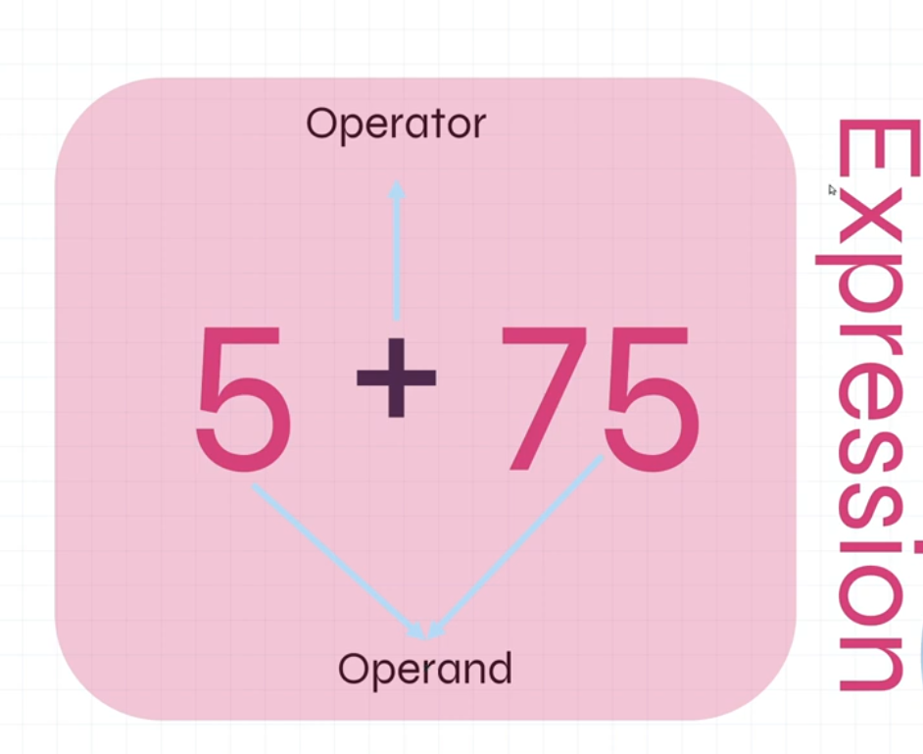

10. Operators

## **Assignment =**

<script>

let age = "24" *// = called assignment operator*

console.log(age);

</script>

## **Addition +**

<script>

let a = 5;

let b = 5;

let c = a + b;

console.log(c);

</script>

## **Subtraction -**

<script>

let a = 15;

let b = 5;

let c = a - b;

console.log(c);

</script>

## **Multiplication \***

<script>

let a = 15;

let b = 5;

let c = a * b;

console.log(c);

</script>

## **Division /**

<script>

let a = 15;

let b = 5;

let c = a / b;

console.log(c);

</script>

## 

## 

## 

## **Modulus %**

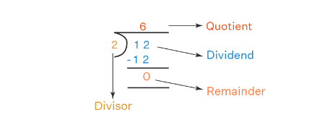

<script>

let a = 17;

let b = 5;

let c = a % b;

console.log(c); *//output remainder 2*

*//Get quotient + remainder both*

*let a = 39;*

*let b = 5;*

*function techyBuzz() {*

*console.log("quotient = " + Math.floor(a / b))*

*console.log("remainder = " + a % b);*

*}*

*techyBuzz()*

</script>

12. Comparison Operators

**== | === | != | !== | < | > | <= | >=**

<script>

let a = 10;

let b = "10";

let c = a == b;

console.log(c); *//Output is true*

c = a === b;

console.log(c); *//Output is false check data type as well*

</script>

13. Logical Operators **&&** | **||** | **!**

<script>

let a = 5;

let b = 10;

console.log(a > b || b > a);

*//true if one of them is true (Output: true)*

console.log(a > b && b > a);

*//true if both are true (Output: false)*

*// ! operator for true to false | false to true*

console.log(!(a > b && b > a)); *(Output: true)*

</script>

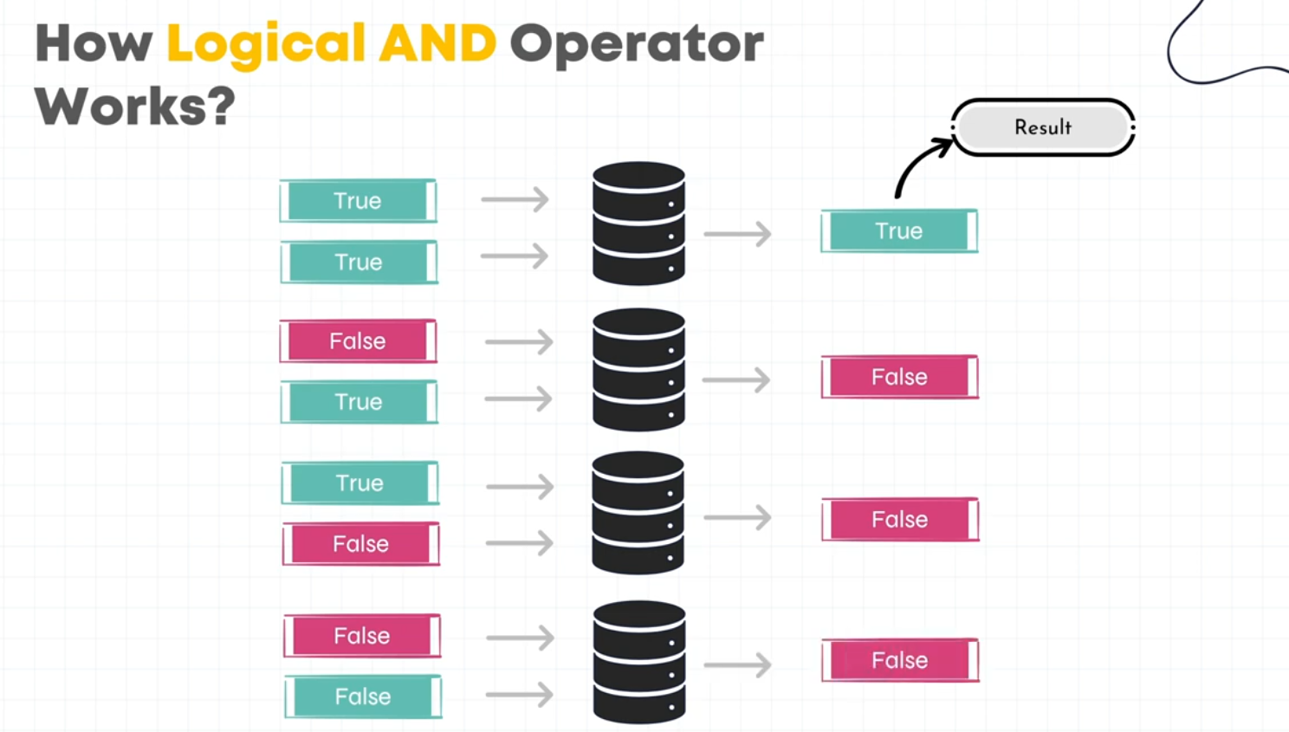

<script>

let age = 18;

let drivingLicence = true;

let canDrive = ((age >= 18) && drivingLicence);

console.log(canDrive); *//Output is true if both conditions are true*

</script>

14. Conditional (**ternary**) Operator

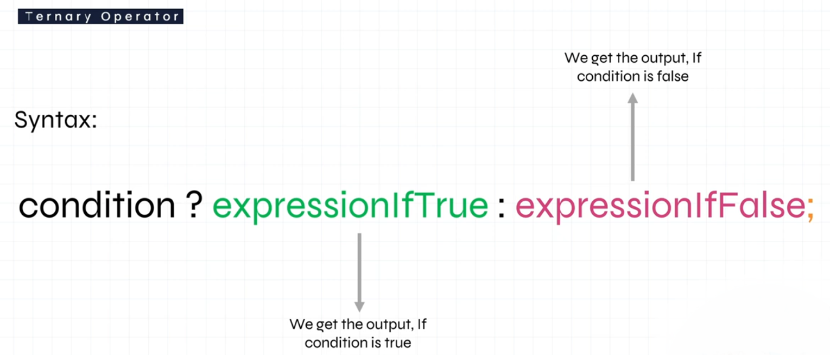

<script>

let age = 18;

let drivingLicence = true;

let canDrive;

canDrive = ((age >= 18) && drivingLicence) ? canDrive = true : canDrive = false;

console.log(canDrive);

</script>

15. If Else Condition

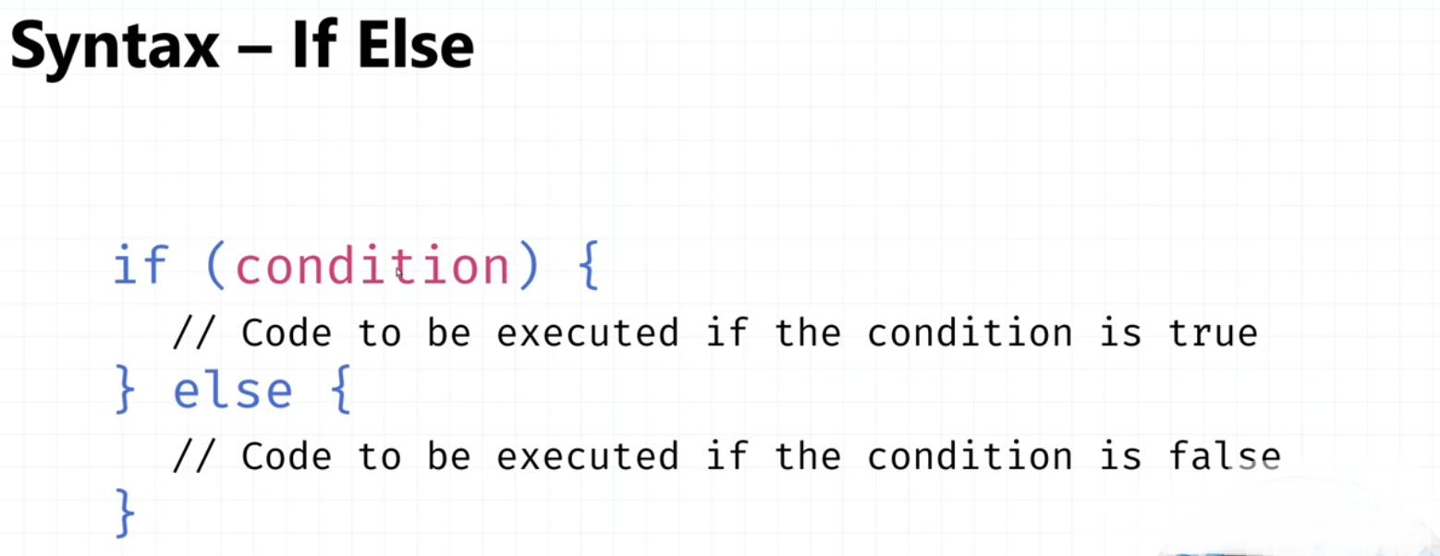

<script>

let age = 18;

if (age >= 18) {

console.log("You can Vote");

} else {

console.log("You can't Vote");

}

</script>

<script>

let age = 18;

let isCitizen = true;

let isRegistered = true;

if (age >= 18) {

if (isCitizen) {

if (isRegistered) {

console.log("You are eligible to Vote");

} else {

console.log("You aren't eligible due to Registration status");

}

} else {

console.log("You aren't eligible due to Citizenship status");

}

} else {

console.log("You aren't eligible to Vote");

}

</script>

16. Switch Statement

<script>

let day;

switch (new Date().getDay()) {

case 0:

day = "Sunday";

break;

case 1:

day = "Monday";

break;

case 2:

day = "Tuesday";

break;

case 3:

day = "Wednesday";

break;

case 4:

day = "Thursday";

break;

case 5:

day = "Friday";

break;

case 6:

day = "Saturday";

break;

default:

day = "default day"

}

console.log("Today is " + day);

</script>

17. While loop

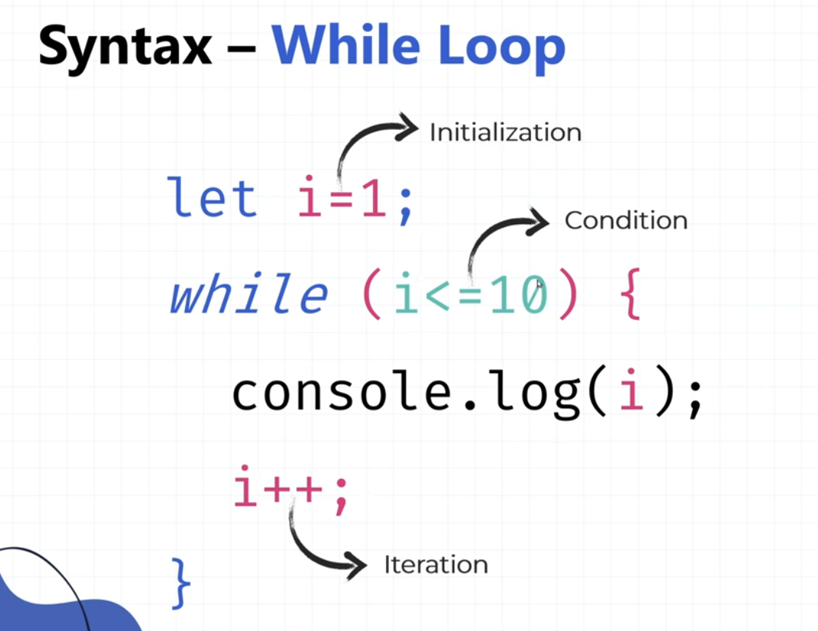

<script>

let i = 1;

while (i <= 10) {

*// do your work here*

console.log(i);

i++;

}

</script>

18. Do while loop

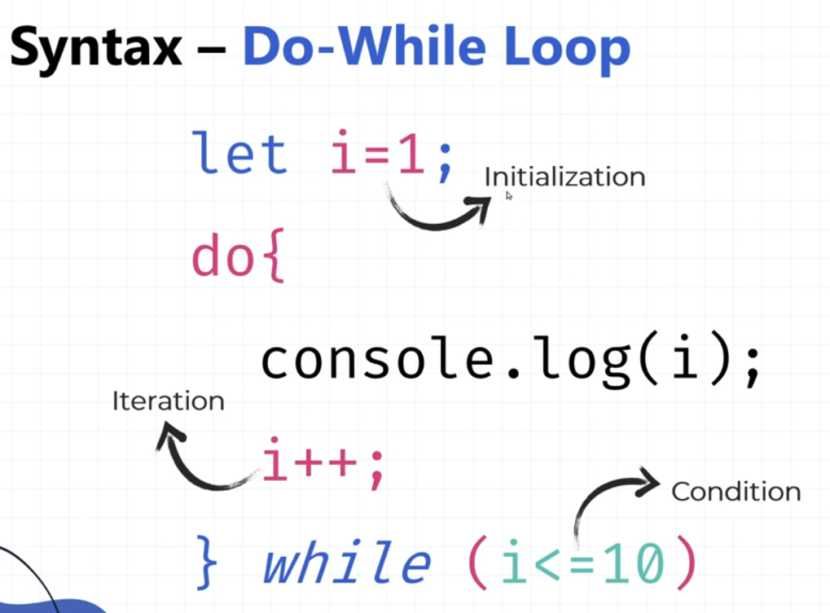

The main difference between the two loops is that the while loop checks the condition before the execution of the statement(s) whereas the **do-while loop** ensures that the statement(s) are **executed at least once before evaluating the condition**. While loop is entry-controlled and Do-while is exit controlled

<script>

let j = 100;

do {

console.log(j);

j++;

} while (j < 10);

</script>

19. Functions

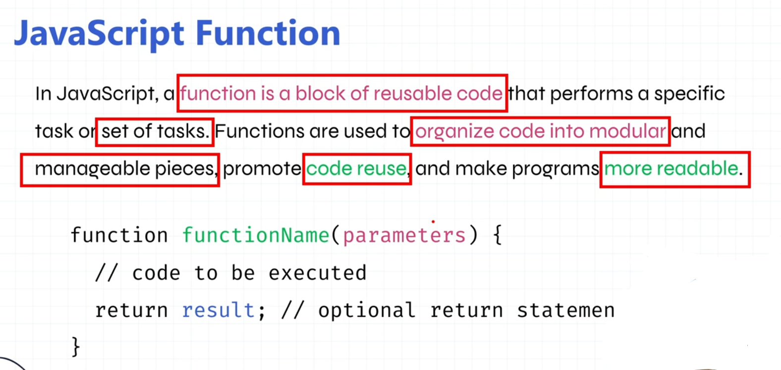

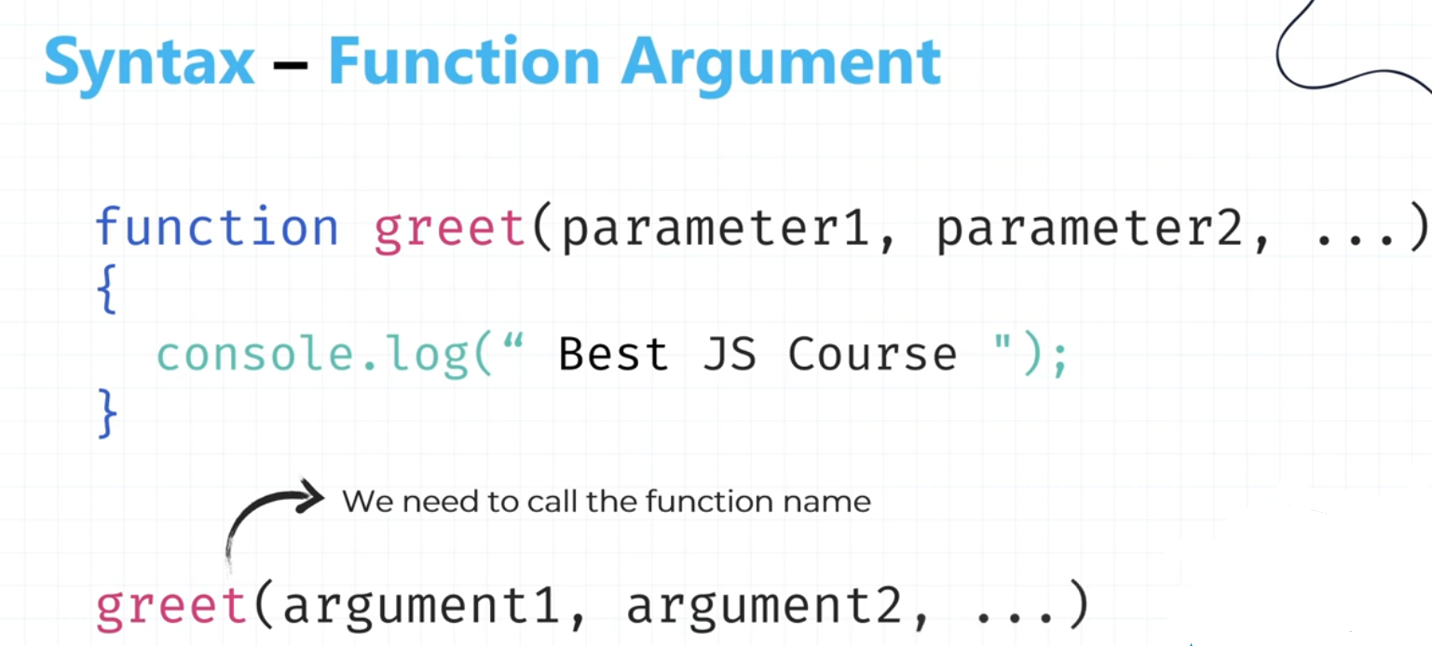

Reusable function with parameters and arguments.

<script>

function sum(*a*, *b*) { // parameters

return *a* + *b*;

}

console.log(sum(5, 10)); // arguments

</script>

function with default arguments

<script>

function sum(*a=5*, *b=5*) { // default parameters if not arg pass while func call

return *a* + *b*;

}

console.log(sum()); // arguments

</script>

<script>

function greet(*name*) {

console.log("Hello " + *name* + ", Welcome to JS course!");

}

greet("Mohit");*//Hello Mohit, Welcome to JS course!*

greet("Rahul");*//Hello Rahul, Welcome to JS course!*

</script>

20. Function expressions

Syntax for Function Expression (anonymous):

<script>

let result = function (*a*, *b*) {

console.log(*a* + *b*);

}

result(5, 10);

</script>

Syntax for Function Expression (named):

<script>

let result = function sum(*a*, *b*) {

console.log(*a* + *b*);

}

result(5, 10);

</script>

Syntax for Arrow Function:

<script>

let result = (*a*, *b*) => {

console.log(*a* + *b*);

}

result(5, 10);

</script>

Store function's call or return data in variable

<script>

function sum(*a*, *b*) {

return *a* + *b*;

}

let result = sum(5, 100); *// store function's value or return data in variable*

console.log(result);

</script>

21. IIFE Function

An IIFE (Immediately Invoked Function Expression) is a JavaScript function that runs as soon as it is defined

<script>

(function (*a*, *b*) {

console.log(*a* + *b*);

})(5, 100)

</script>

Store IIFE in variable.

<script>

let sum = (function (*a*, *b*) {

return *a* + *b*;

})(5, 100)

console.log(sum);

</script>

22. EcmaScript start

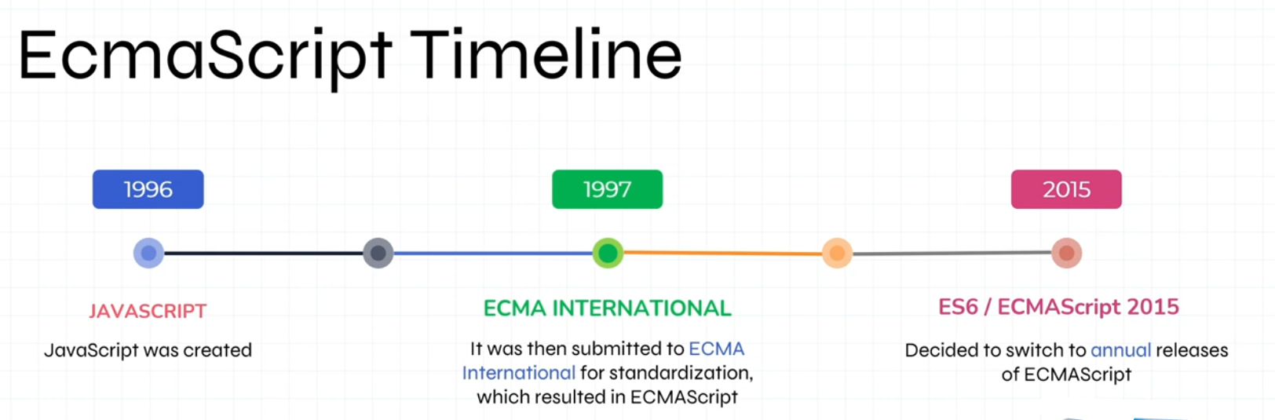

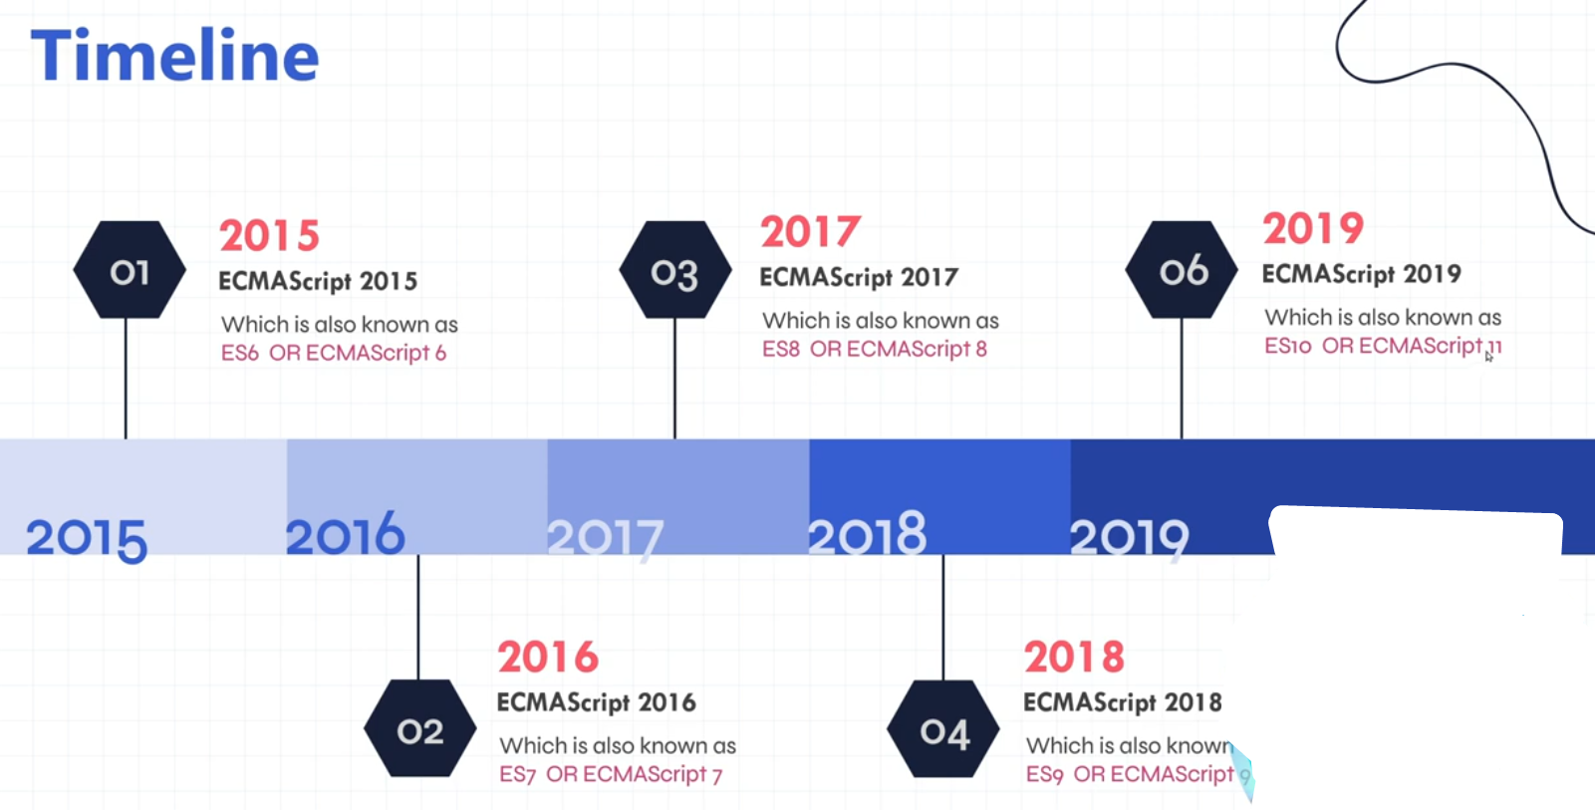

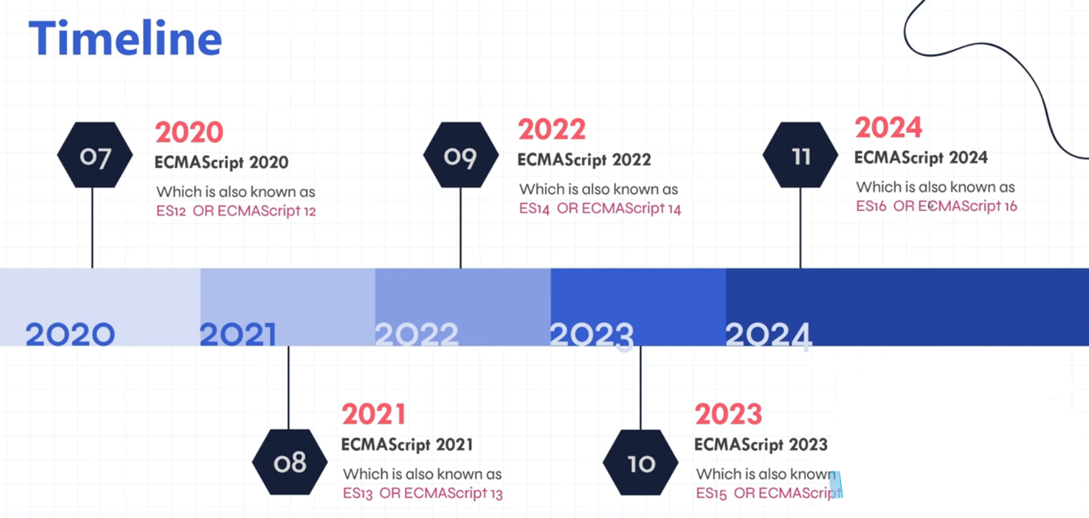

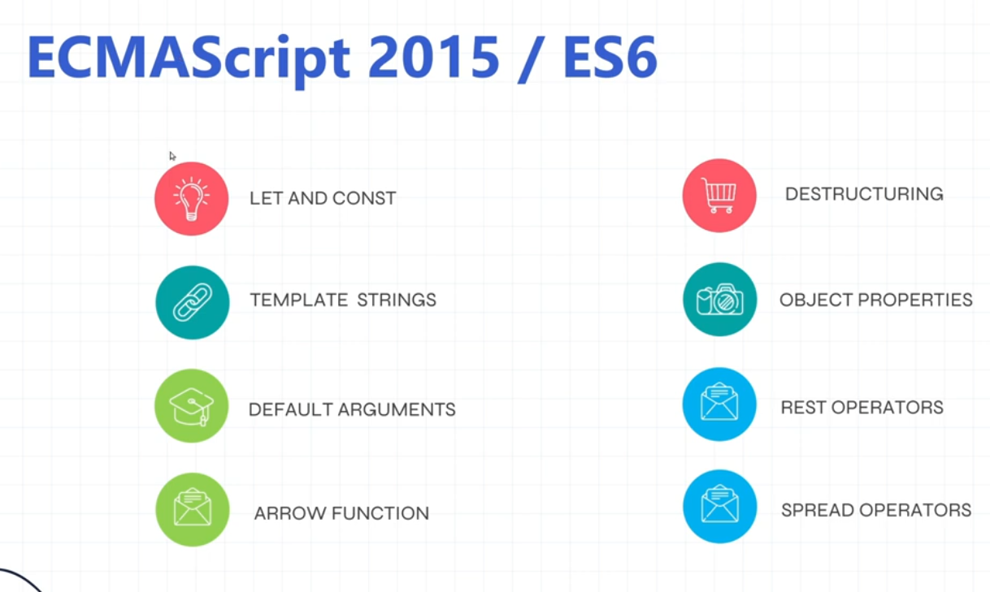

## **VAR, LET AND CONST**

<https://www.geeksforgeeks.org/difference-between-var-let-and-const-keywords-in-javascript/>

**Var**

**<script>**

***// using block scope***

**if (true) { *//block scope***

**var a = 10;**

**var a = 100; *// Variables declared with var can also be redeclared and reassigned.***

**}**

**console.log(a); *//output = 10***

***// using function scope***

**function test() { *// function scope***

**var b = 5;**

**}**

**test();**

**console.log(b); *//output = Uncaught ReferenceError: b is not defined***

**</script>**

## **Template string or template literals**

<script>

*// template strings or template literals*

var firstName = "Mohit";

var lastName = "Verma";

*// Old way*

var fullName = firstName + lastName;

console.log(fullName); *//Output = MohitVerma*

*// New way using template strings*

var fullName = `${firstName} ${lastName}`;

console.log(fullName); *//Output = Mohit Verma*

</script>

## **function with default arguments**

<script>

function sum(*a=5*, *b=5*) { // default parameters if not arg pass while func call

return *a* + *b*;

}

console.log(sum()); // arguments

</script>

## **Fat arrow function**

<script>

let sum = (*a*, *b*) => {

console.log(*a* + *b*);

}

sum(5, 10);

</script>

<script>

*// if single line of code then don't use curly braces for one line*

let sum = (*a*, *b*) => console.log(*a* + *b*);

sum(5, 10);

</script>

23. Slice method for string

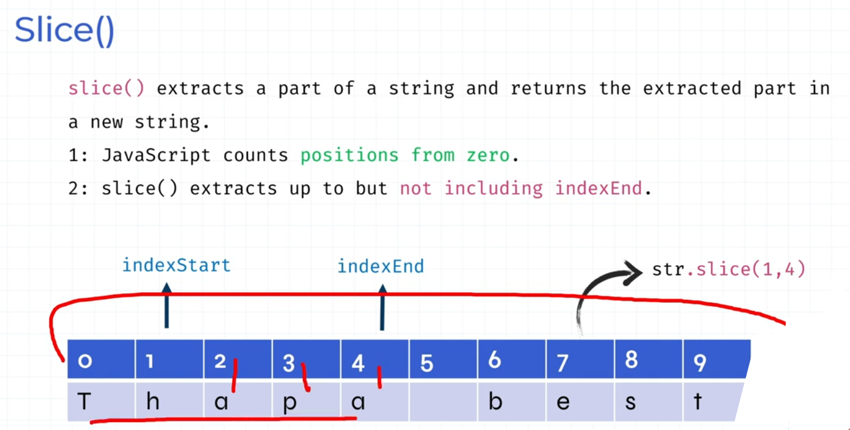

<script>

let myName = "Mohit Verma";

console.log(myName); *//Output = Mohit Verma*

console.log(myName[0]); *//Output = M*

console.log(myName.slice(1, myName.length - 1)); *//Output = ohit Verm*

</script>

24. Arrays

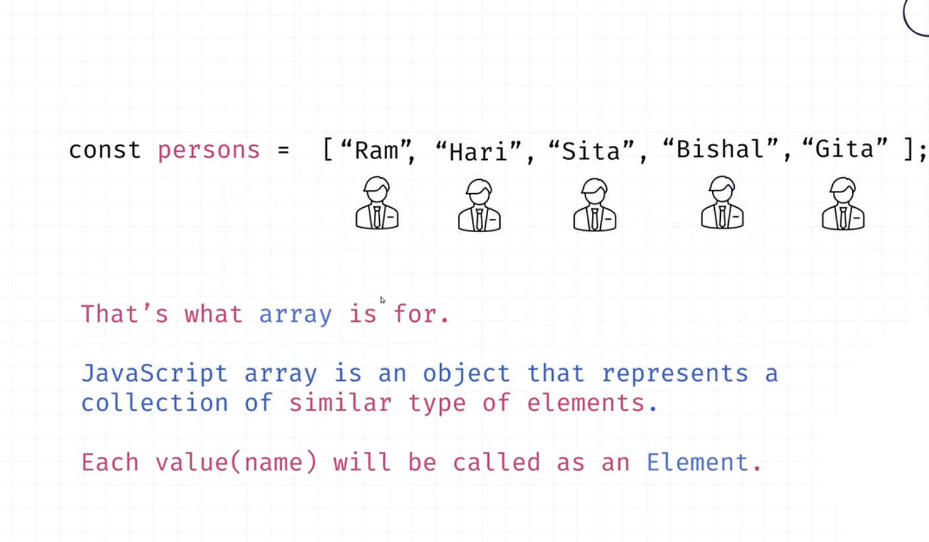

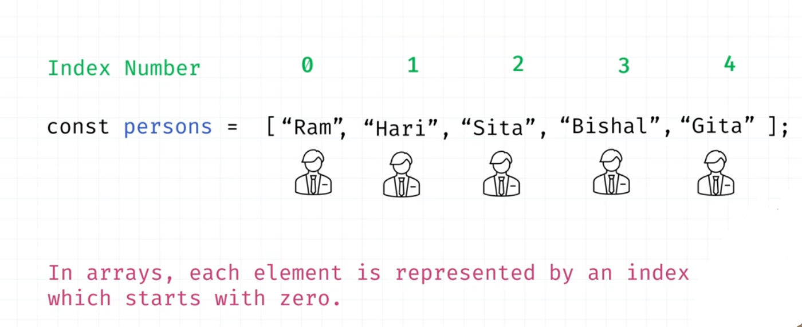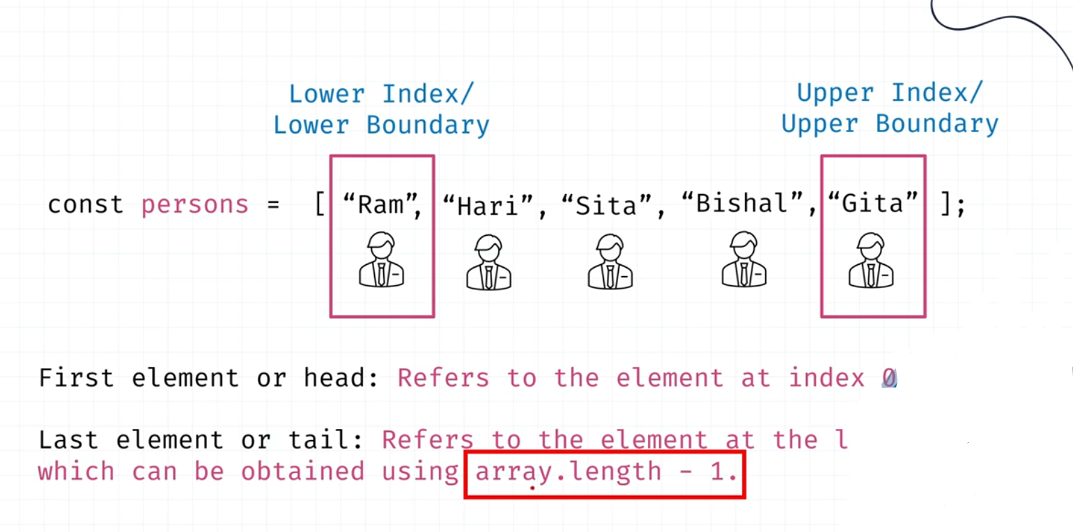

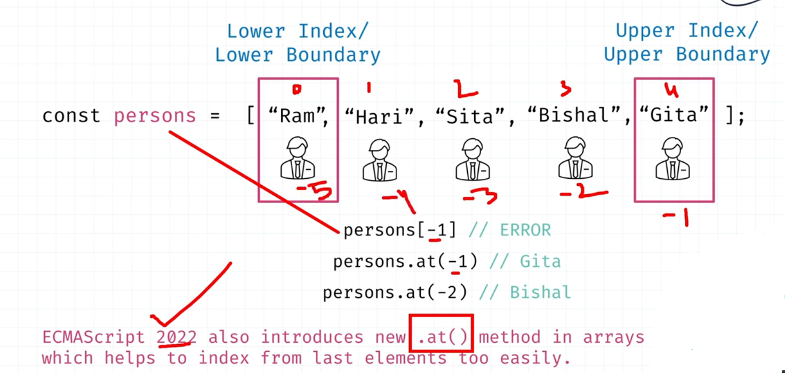

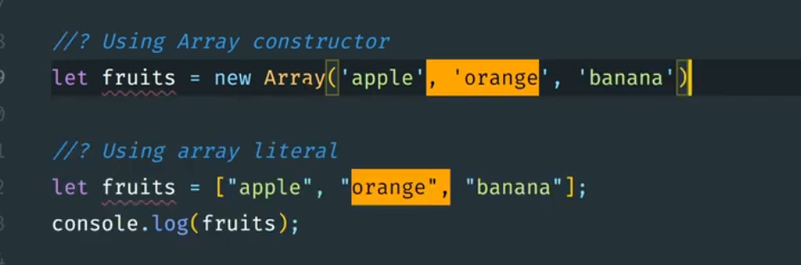

## **- Create and modify array**

<script>

*// Create an array*

let fruits = ["Apple", "Mango", "Orange"];

console.log(fruits); *//Output = ['Apple', 'Mango', 'Orange']*

console.log(typeof fruits); *//Output = Object*

*// Modify array*

fruits[2] = "Banana";

console.log(fruits); *//Output = ['Apple', 'Mango', 'Banana']*

</script>

## **- Iterate array values**

### **For of loop**

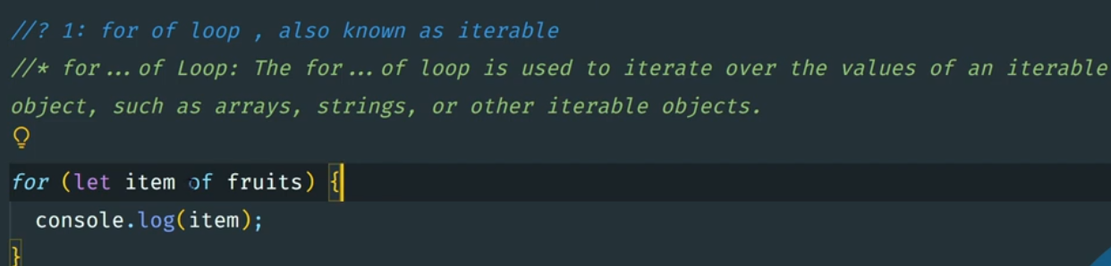

<script>

let fruits = ["Apple", "Mango", "Orange"];

for (const fruit of fruits) {

console.log(fruit);

}

</script>

### **For in loop**

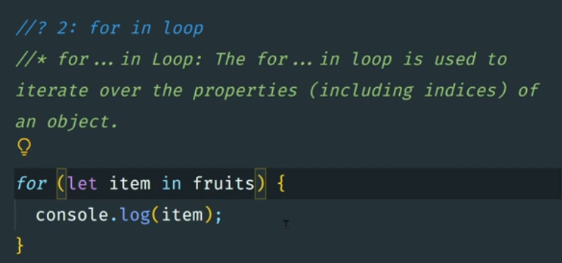

<script>

let fruits = ["Apple", "Mango", "Orange"];

for (const fruit in fruits) {

console.log(fruit); *//Output = index*

console.log(fruits[fruit]); *//Output = value*

}

</script>

### 

### **For each loop**

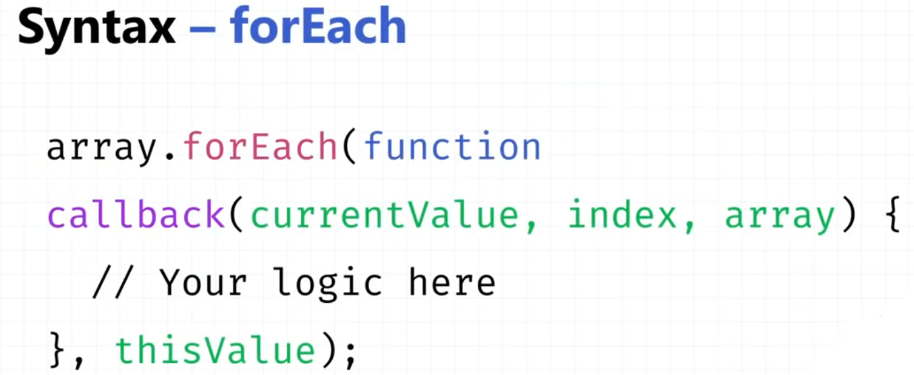

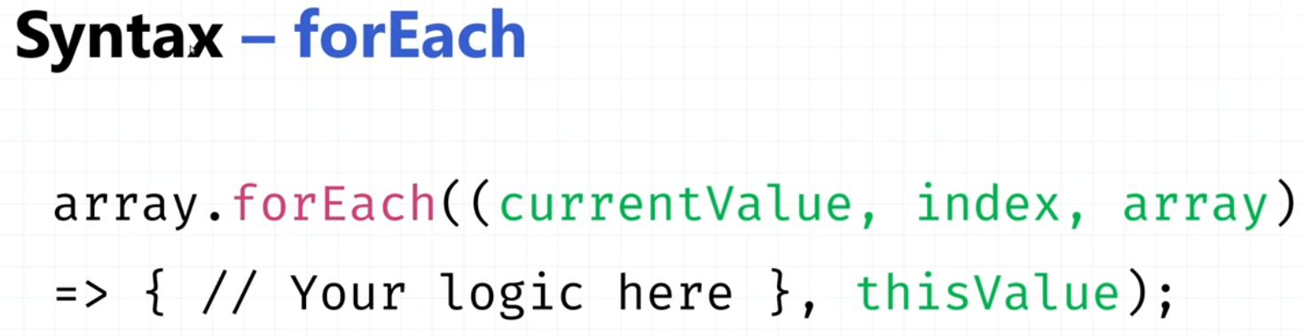

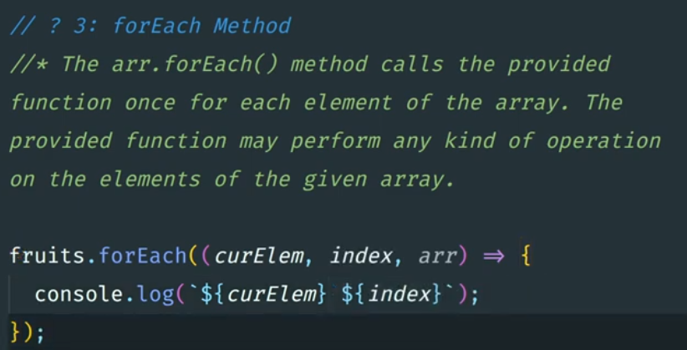

<script>

let fruits = ["Apple", "Mango", "Orange"];

fruits.forEach((*item*, *index*, *arr*) => {

console.log(*item*);

console.log(*index*);

console.log(*arr*);

});

</script>

### **Map method**

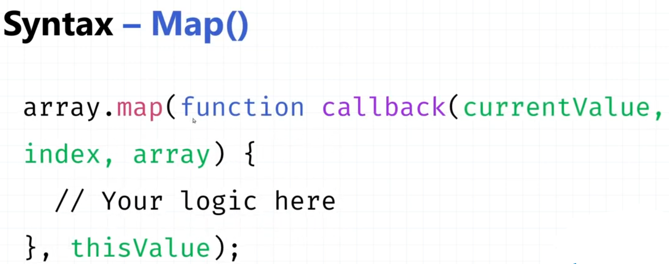

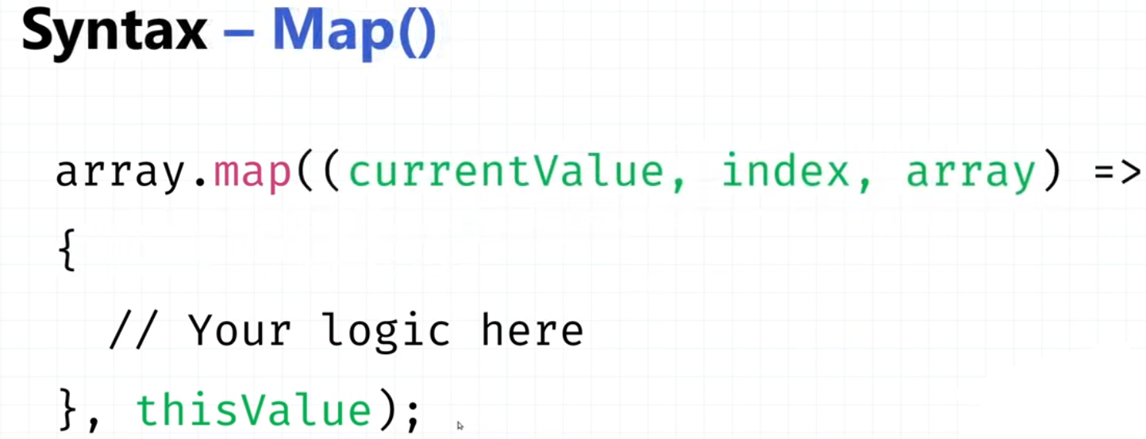

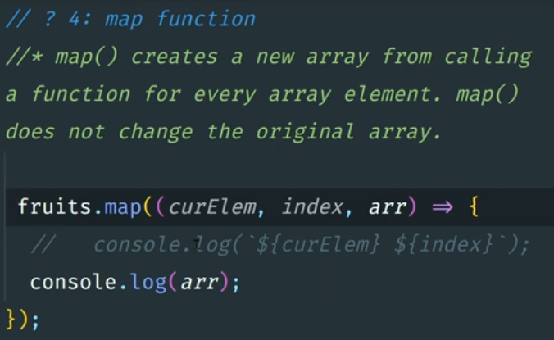

<script>

let fruits = ["Apple", "Mango", "Orange"];

const newArr = fruits.map((*item*, *index*, *arr*) => {

return `${*item*} ${*index*}`;

});

console.log(newArr); *//Output = ['Apple 0', 'Mango 1', 'Orange 2']*

console.log(fruits); *//Output = ['Apple', 'Mango', 'Orange']*

</script>

### **Difference between forEach & map 👇**

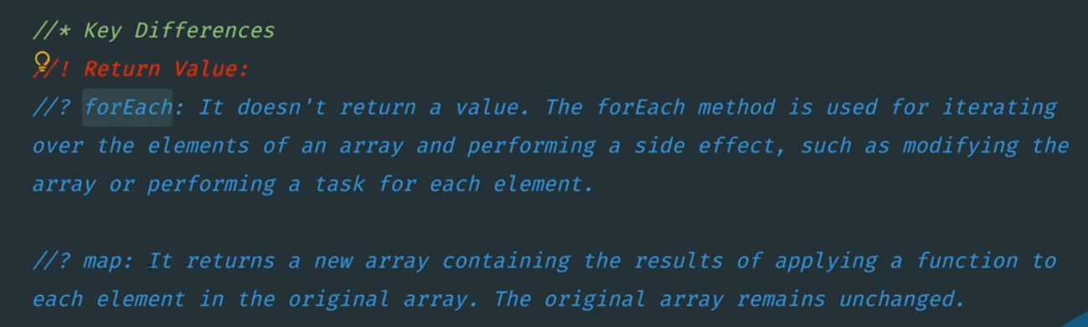

### **- Push method**

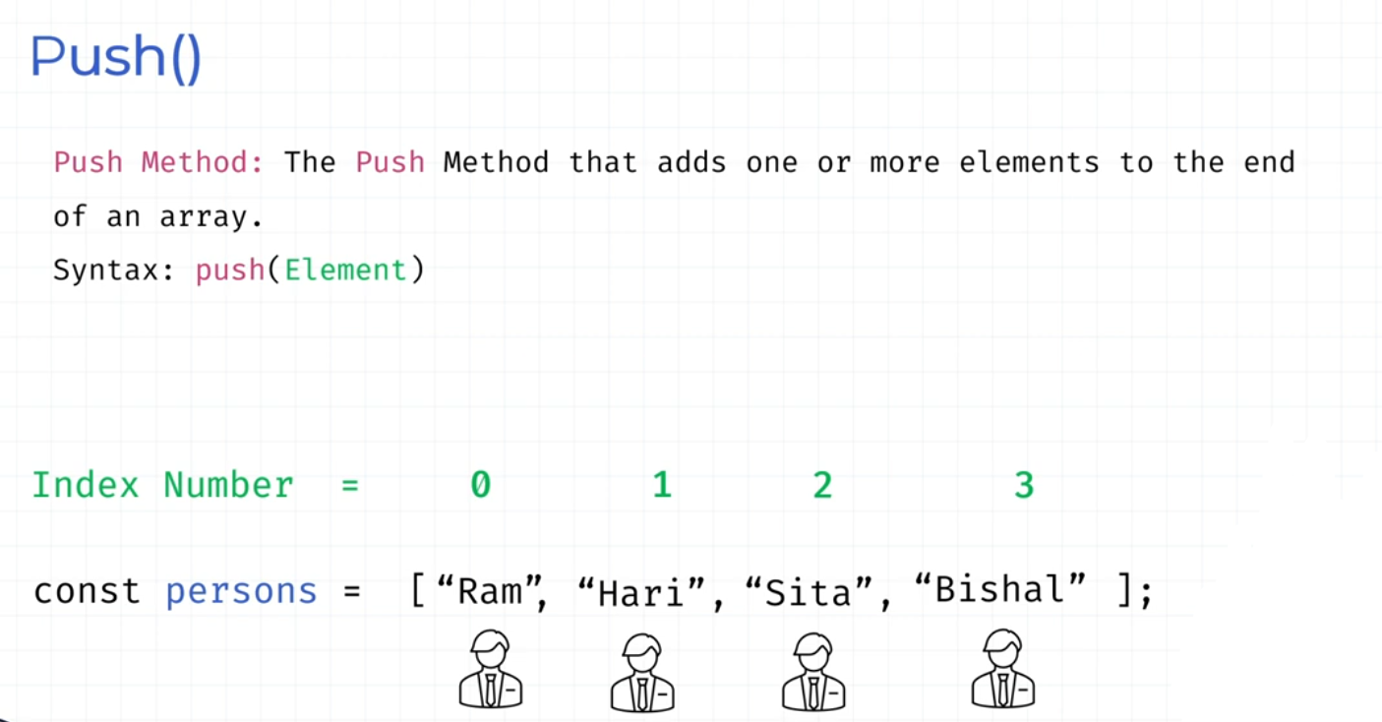

<script>

let fruits = ["Apple", "Mango", "Orange"];

fruits.push("Banana");

console.log(fruits); *//Output = ['Apple', 'Mango', 'Orange', 'Banana']*

</script>

### **- Pop method**

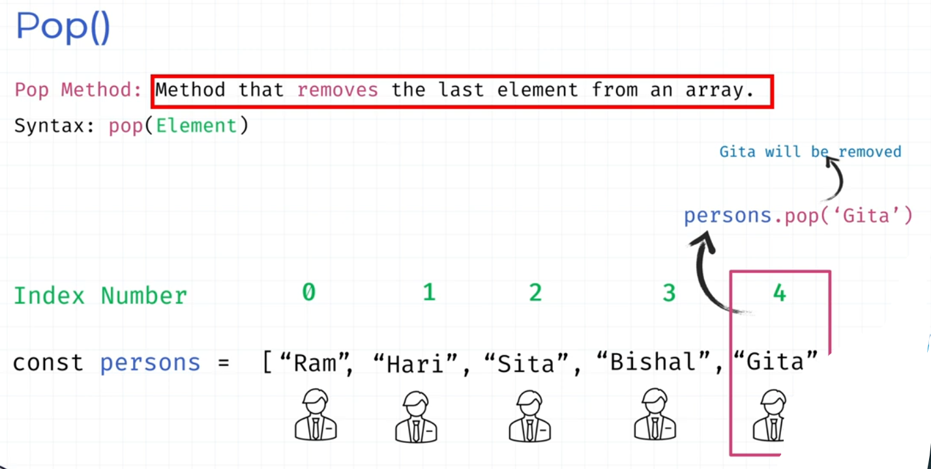

<script>

let fruits = ["Apple", "Mango", "Orange"];

fruits.pop();

console.log(fruits); *//Output = ['Apple', 'Mango']*

</script>

### **- Unshift method**

The **unshift()** method adds new elements to the **beginning of an array.** The unshift() method overwrites the original array.

<script>

let fruits = ["Apple", "Mango", "Orange"];

fruits.unshift("Banana");

console.log(fruits); *//Output = ['Banana', 'Apple', 'Mango', 'Orange']*

</script>

### **- Shift method**

The **shift()** method removes the element at the **zeroth 0 index.**

<script>

let fruits = ["Apple", "Mango", "Orange"];

fruits.shift();

console.log(fruits); *//Output = ['Mango', 'Orange']*

</script>

### **- Splice method**

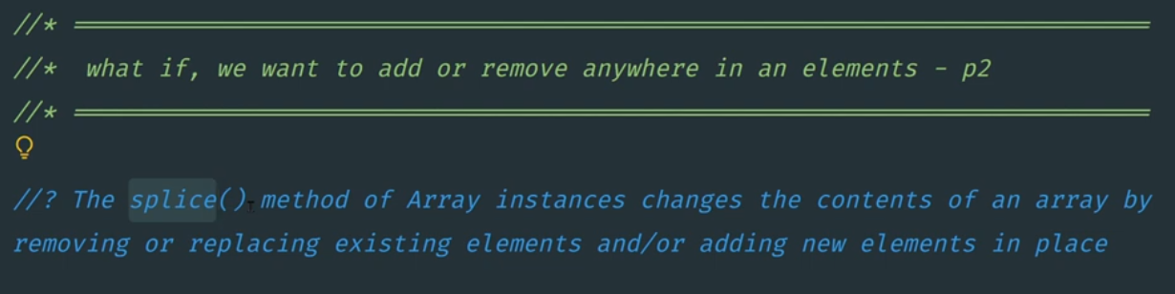

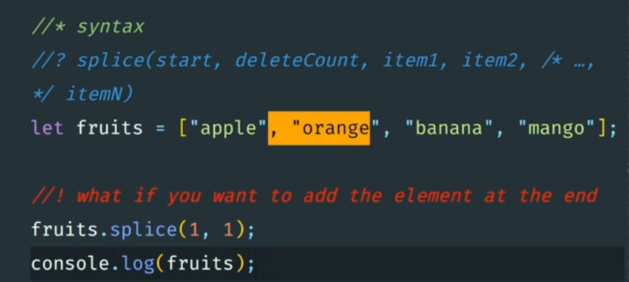

<script>

let fruits = ["Apple", "Mango", "Orange"];

fruits.splice(1, 1);

console.log(fruits); *//Output = ['Apple', 'Orange']*

</script>

#### **Delete and replace** 👇

<script>

let fruits = ["Apple", "Mango", "Orange"];

fruits.splice(1, 1, "Banana");

console.log(fruits); *//Output = ['Apple', 'Banana', 'Orange']*

</script>

#### **Only add using splice**

If you don’t want to delete only add at end of an array using **splice method**

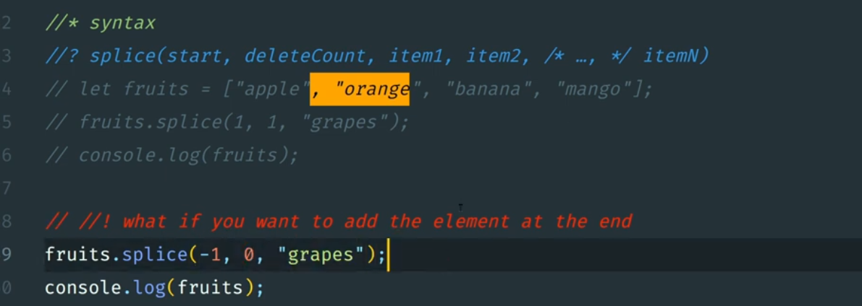

<script>

let fruits = ["Apple", "Mango", "Orange"];

fruits.splice(0, 0, "Banana"); *// at start of an array*

console.log(fruits); *//Output = ['Banana', 'Apple', 'Mango', 'Orange']*

fruits.splice(fruits.length, 0, "grapes"); *// at end of an array*

console.log(fruits); *//Output = ['Banana', 'Apple', 'Mango', 'Orange', 'grapes']*

</script>

### **- IndexOf method**

The **indexOf**() method returns the first index (position) of a specified value. The indexOf() method returns -1 if the value is not found.

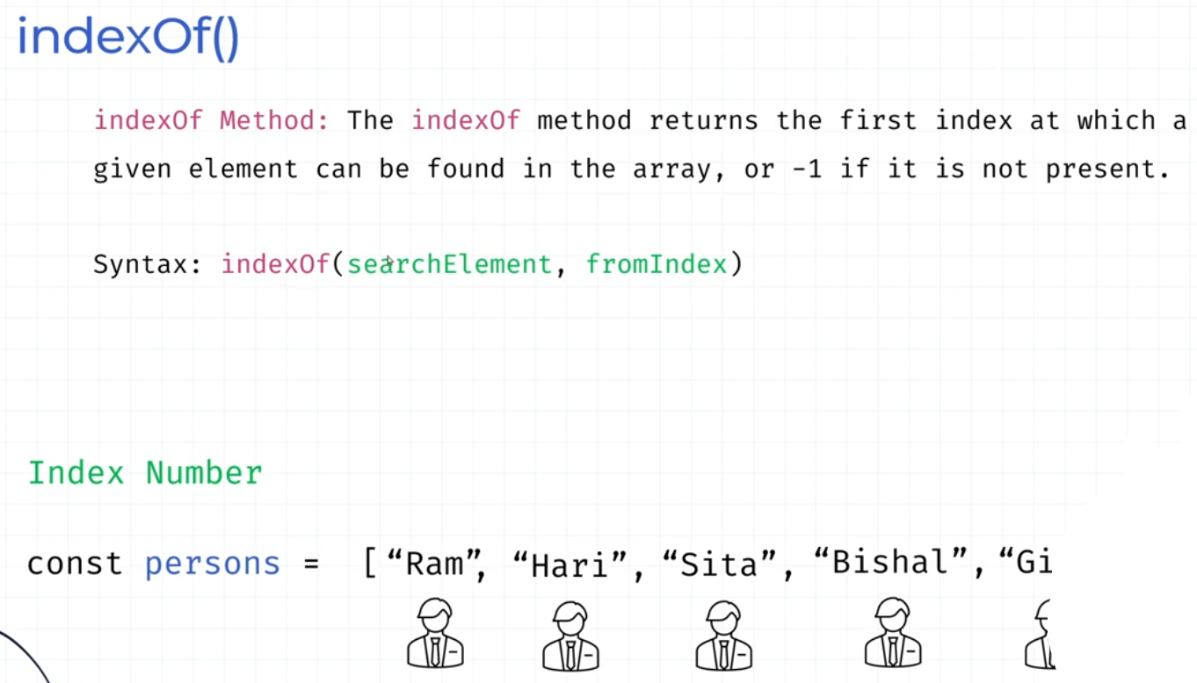

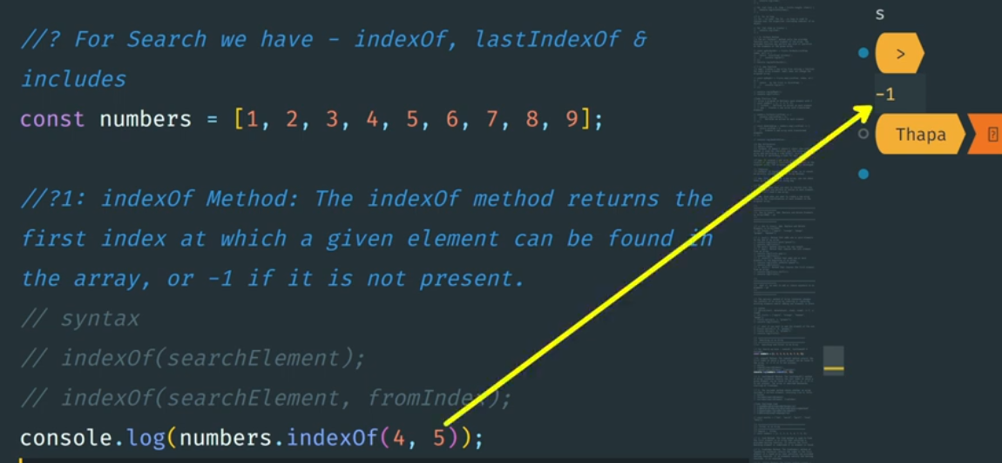

<script>

let fruits = ["Apple", "Mango", "Orange"];

console.log(fruits.indexOf("Orange")); *//Output = 2*

</script>

### **- lastIndexOf method**

The **lastIndexOf**() starts at a specified index and searches from right to left

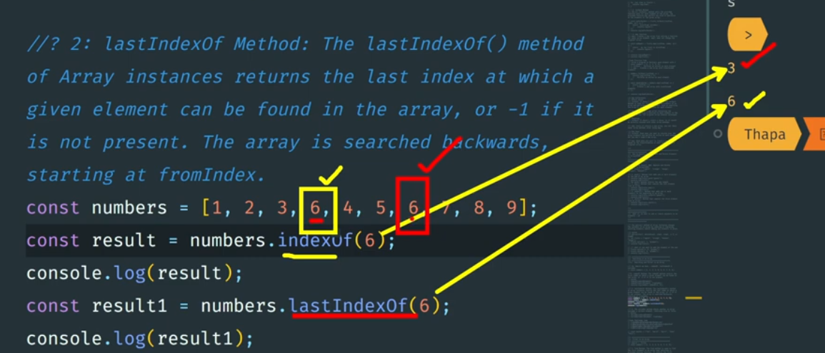

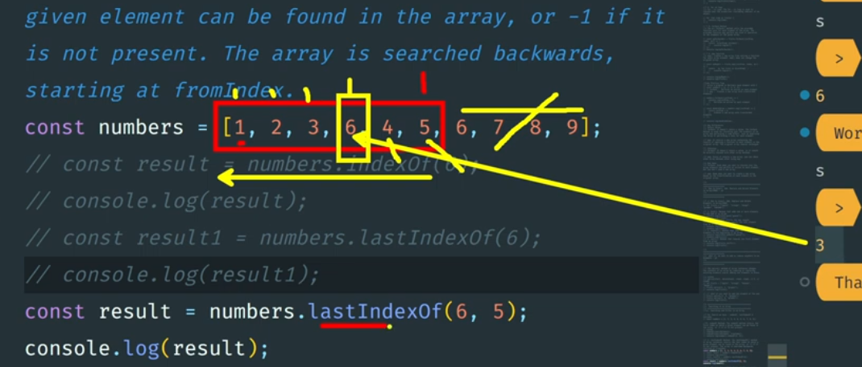

<script>

let fruits = ["Apple", "Mango", "Orange", "Mango", "Apple"];

console.log(fruits.lastIndexOf("Mango")); *//Output = 3*

</script>

### **- Includes method**

JavaScript Array **includes**()​​ The includes() method returns true if an array contains a specified value.

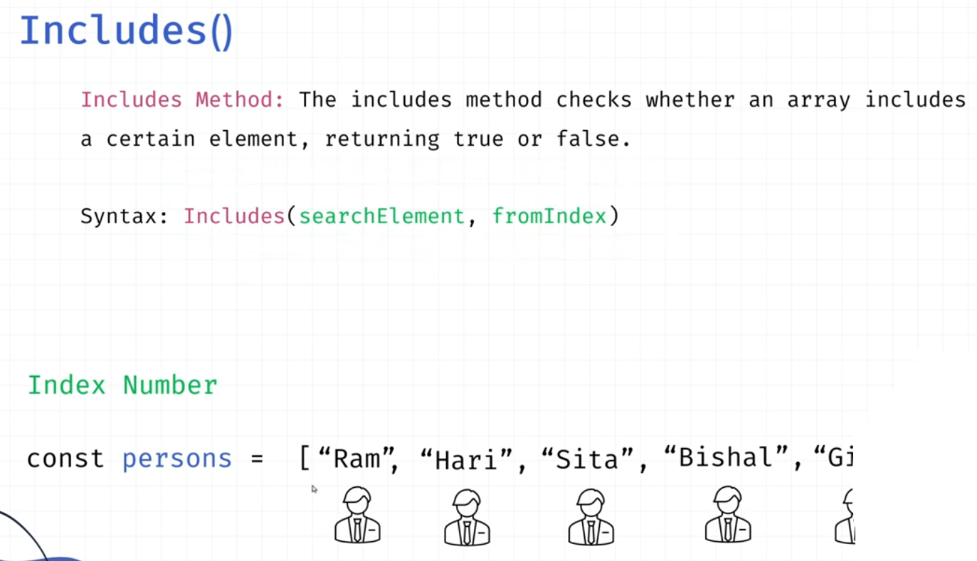

<script>

let fruits = ["Apple", "Mango", "Orange"];

console.log(fruits.includes("Orange")); *//Output = true*

</script>

### **- Find method**

**find()** returns the value of the first element in an array that passes a test (provided by a function):

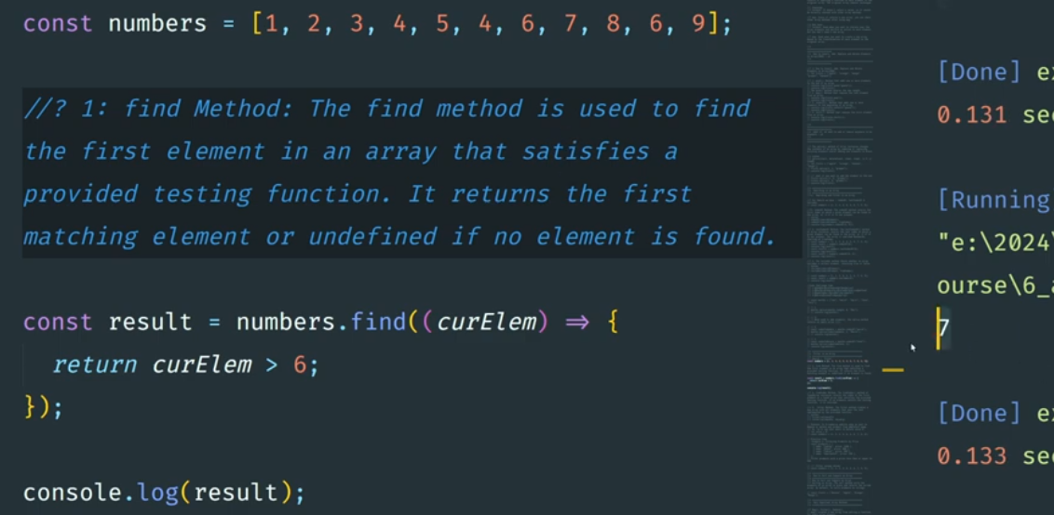

<script>

let numbers = [1, 2, 3, 4, 5, 6, 7, 8, 9];

let findInNumbers = numbers.find(*element* => {

return *element* > 5;

});

console.log(findInNumbers); *//Output = 6*

</script>

### **- FindIndex method**

**findIndex()** returns the index of the first element that passes a test (provided by a function).

<script>

let numbers = [1, 2, 3, 4, 5, 6, 7, 8, 9];

let findInNumbers = numbers.findIndex(*element* => {

return *element* > 5;

});

console.log(findInNumbers); *//Output = 5 because 6 is greater than 5 & index of 6 is = 5*

</script>

### **- Filter method**

The **filter()** method creates a new array filled with elements that pass a test provided by a function.

<script>

let numbers = [1, 2, 3, 4, 5, 6, 7, 8, 9];

let findInNumbers = numbers.filter(*element* => {

return *element* > 5;

});

console.log(findInNumbers); *//Output = [6, 7, 8, 9]*

</script>

### **- new Set method**

A set is essentially a group of items where each item is unique, meaning no element is repeated within it.

<script>

let mySet = new Set([1, 2, 3, 4, 4, 5]);

console.log(mySet); *// Output: Set(5) {1, 2, 3, 4, 5}*

console.log(mySet.size); *// Output: 5*

mySet.add(6); *//add in set*

console.log(mySet); *// Output: Set(5) {1, 2, 3, 4, 5}*

console.log(mySet.size); *// Output: 6*

</script>

### **- Sort method**

The **sort()** method sorts the elements as strings in alphabetical and ascending order. The sort() method overwrites the original array.

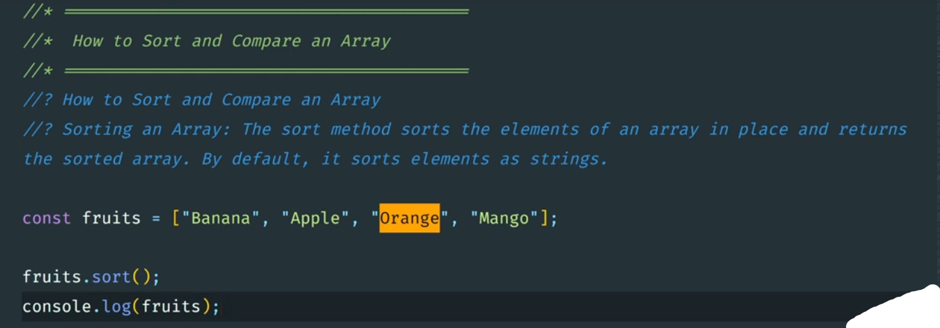

<script>

let fruits = ["Mango", "Apple", "Orange", "Banana"];

fruits.sort();

console.log(fruits); *//Output = ['Apple', 'Banana', 'Mango', 'Orange']*

</script>

#### **Sort with numbers**

<script>

let points = [1, 5, 10, 4, 103, 9];

points.sort(function (*a*, *b*) {

*// return a - b //lowest to highest in order = [1, 4, 5, 9, 10, 103]*

return *b* - *a* *//highest to lowest in order = [103, 10, 9, 5, 4, 1]*

});

console.log(points);

</script>

### **-Spread operator**

<script>

const firstBowl = ["papaya", "cucumber", "watermelon"];

const secondBowl = ["Pineapple", "Apple", "banana"];

const thirdBowl = ["cashew nut", "Date", "Strawberry"];

const fruitMix = [...firstBowl, ...secondBowl, ...thirdBowl];

console.log(fruitMix);

</script>

### **-Reduce method**

<script>

const products = [100, 200, 300, 400, 500];

const total = products.reduce((*acc*, *element1*) => { *//acc is accumulator*

return *acc* + *element1*

}, 0); *//acc is initial value set to 0*

console.log(total);

</script>

<script>

const numbers = [175, 50, 25];

let reduced = numbers.reduce(

(*zeroIndex*, *currentValue*, *currentIndex*, *arr*) => {

*zeroIndex* = *zeroIndex* + *currentValue*;

return *zeroIndex*;

},

5

); *// you can set initial value here*

console.log(reduced); *//output = 255 with initial value*

</script>

<script>

const numbers = [175, 50, 25];

let reduced = numbers.reduce(

(*zeroIndex*, *currentValue*, *currentIndex*, *arr*) => {

*zeroIndex* = *zeroIndex* - *currentValue*;

return *zeroIndex*;

}

); *// you can set initial value here*

console.log(reduced); *//output = 100*

</script>

25. Strings

## **-length**

Length start from 1 whereas index start from 0.

<script>

let myName = "Mohit Verma";

console.log(myName.length); *//output = index.html:88 11*

</script>

## **-Single quote in string**

<script>

let myName = "My name is 'Mohit Verma'";

console.log(myName); *//output = My name is 'Mohit Verma'*

</script>

## **-Double quote in string**

<script>

*// double quote in string*

let myName = 'My name is "Mohit Verma"';

console.log(myName); *//output = My name is "Mohit Verma"*

</script>

## **-Both quotes in string**

<script>

*// single double quotes in string*

let myName = "My 'name' is \"Mohit Verma \"";

console.log(myName); *//output = My 'name' is "Mohit Verma "*

</script>

## **-New line in string - \n**

<script>

*// single double quotes in string*

let myName = "My 'name' is \"Mohit Verma\" \nI am a web designer";

console.log(myName);

*//output = My 'name' is "Mohit Verma"*

*// I am a web designer*

</script>

## **-Backslash in string - \\** use double slash

*// backslash in string*

let myName = "My 'name' is \"Mohit Verma\" \nI am a \\web designer\\";

console.log(myName);

*//output = My 'name' is "Mohit Verma"*

*// I am a \web designer*

</script>

## **-indexOf() in string**

<script>

let myName = "My name is Mohit Verma";

console.log(myName.indexOf("Mohit")); *//output is 11 index number of str at first occurrence*

</script>

## **-Convert string to array - split() in string**

<script>

let text = "How are you doing today?";

const myArray = text.split("");

console.log(myArray);

</script>

## **-lastIndexOf() in string - right to left**

<script>

let myName = "My name is Mohit name Verma";

console.log(myName.lastIndexOf("name")); *//output is 17 not 3 from last*

</script>

## **-Search() in string**

<script>

let myName = "My name is Mohit name Verma";

console.log(myName.search(/namE/i)); *// search accept regex and i accept case sensitive*

</script>

## **-match() in string**

<script>

let myName = "My name is Mohit name Verma";

console.log(myName.match(/namE/gi)); *// Output = (2) ['name', 'name'] //g for globally search in str*

</script>

## **-matchAll() in string**

<script>

let myName = "My name is Mohit name Verma";

let a = myName.matchAll(/NaMe/gi); *// Use a regular expression with the 'g' flag and i for case sensitive*

console.log(a); *// Output = RegExpStringIterator {}*

*// Since `a` is an iterator, we need to convert it to an array to see the results*

let matches = Array.from(a);

*// Log all matches*

console.log(matches); *// Output = Array of match results*

*// Iterate over the matches and log each item*

for (let item of matches) {

console.log(item); *// Logs the match array, which contains the matched string and other details*

console.log(item[0]); *// Logs the matched string, which is "name" in this case*

}

</script>

## **-includes() in string**

<script>

let myName = "My name is Mohit name Verma";

console.log(myName.includes("y")); *//output = true*

</script>

## **-startsWith() in string**

**startsWith()** method returns true if a string starts with a specified string.

<script>

let myName = "My name is Mohit name Verma";

console.log(myName.startsWith("My")); *//output = true*

</script>

## **-endsWith() in string**

**endsWith()** method of String values determines whether a string ends with the characters of this string.

<script>

let myName = "My name is Mohit name Verma";

console.log(myName.endsWith("Verma")); *//output = true*

</script>

## **-Extract part in string**

#### **-slice()**

#### 

slice() extracts a part of a string and returns the extracted part:

<script>

let text = "Hello world!";

let result = text.slice(0, 5); *//Slice the first 5 positions:*

console.log(result); *//output = Hello*

</script>

<script>

let text = "Hello world!";

let result = text.slice(3); *//From position 3 to the end:*

console.log(result); *//output = lo world!!*

</script>

#### **-substring()**

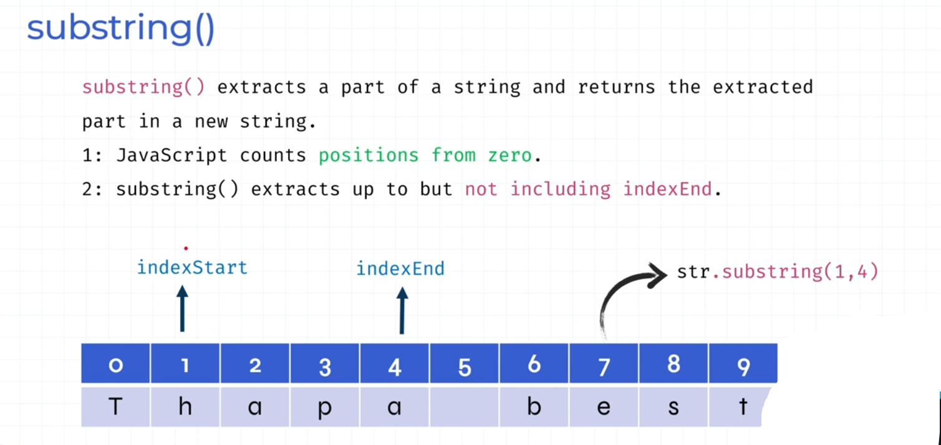

<script>

let text = "Hello world!";

let result = text.substring(3); *//From position 3 to the end:*

console.log(result); *//output = lo world!!*

</script>

#### **-replace()**

<script>

let text = "Hello world! Hello Hello";

let result = text.replace("Hello", "Mohit");

console.log(result); *//output = Mohit world! Hello Hello*

</script>

#### **-replaceAll()**

<script>

let text = "Hello world! Hello Hello";

let result = text.replaceAll("Hello", "Mohit"); *//From position 3 to the end:*

console.log(result); *//output = Mohit world! Mohit Mohit*

</script>

#### **-charAt()**

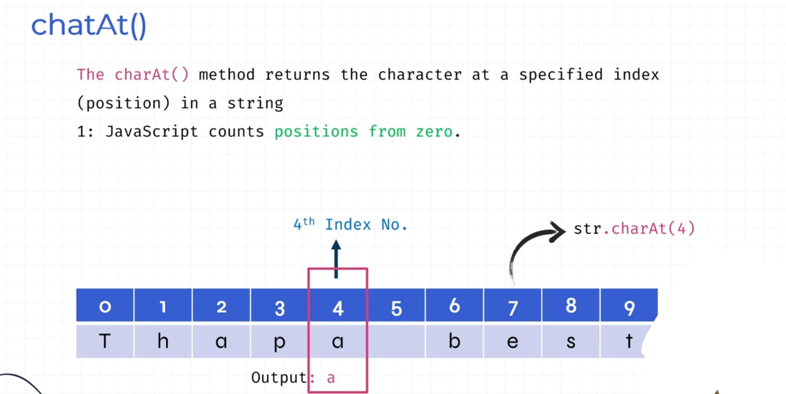

<script>

let text = "Hello world! Hello Hello";

let result = text.charAt(6);

console.log(result); *//output = w*

</script>

#### **-charCodeAt()**

The charCodeAt() method returns the Unicode of the character at a specified index (position) in a string.

<script>

let text = "Hello world! Hello Hello";

let result = text.charCodeAt(6); *// w*

console.log(result); *//output = 119*

</script>

#### **-at()**

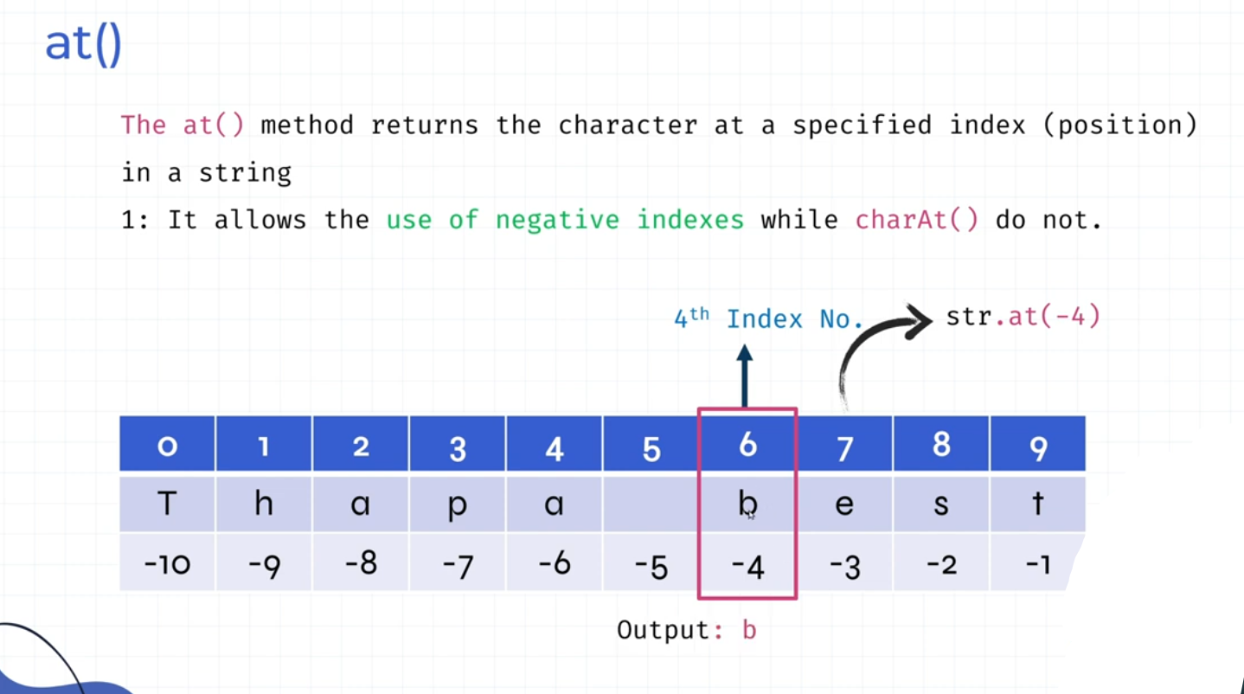

## **-toLowerCase() and toUpperCase() in string**

<script>

let text = "Hello World!";

console.log(text.toLowerCase()); *//output = hello world!*

console.log(text.toUpperCase()); *//output = HELLO WORLD!*

</script>

## **-trim() in string**

<script>

let text = " Hello World! ";

let result = text.trim();

console.log(result); *//Output = Hello World!*

</script>

## **-trim() split() reverse() in string**

<script>

let text = " apple,banana,mango "

let result = text.trim().split(",").reverse();

console.log(result); *//Output = (3) ['mango', 'banana', 'apple']*

</script>

## **-trim() split() reverse() join() in string**

join() for convert array to string

<script>

let text = " apple,banana,mango "

let result = text.trim().split(",").reverse().join();

console.log(result); *//Output = mango,banana,apple - back to string*

</script>

26. Math

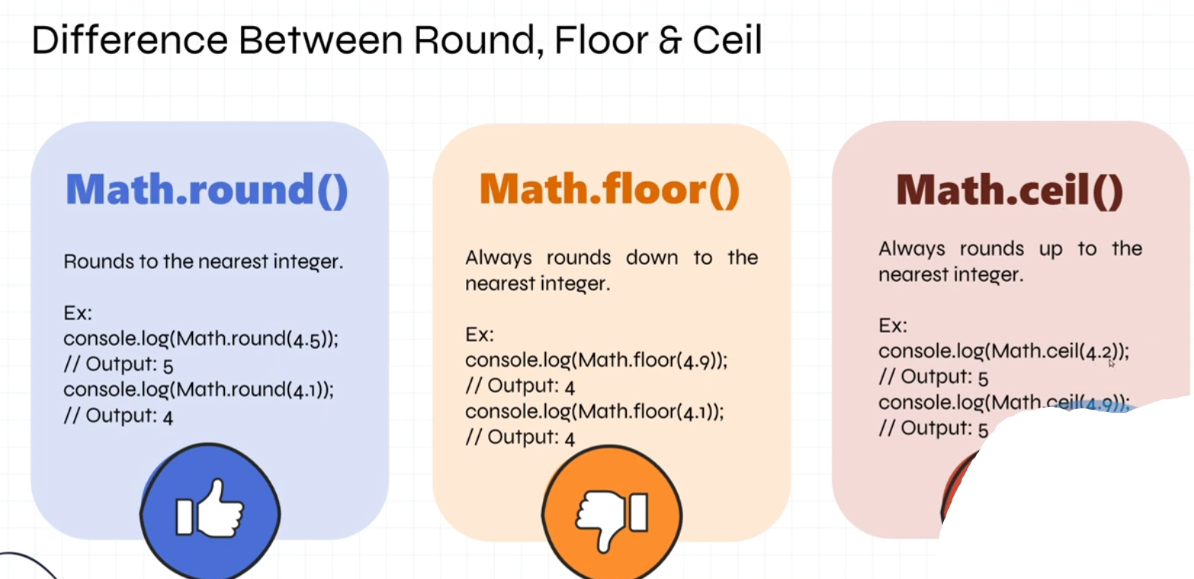

## **-PI value**

<script>

const piVal = Math.PI;

console.log(piVal);

</script>

## **-Math.abs()**

Math.abs() returns the absolute value of a number:

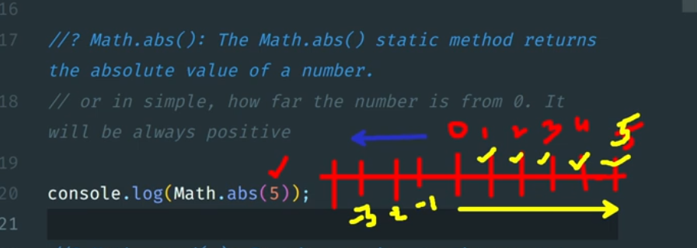

<script>

console.log(Math.abs(-7.25)); *//Output = 7.25*

console.log(Math.abs(-5)); *//Output = 5*

</script>

## **-Math.round()**

The **Math.round()** method rounds a number to the nearest integer.

**2.49** will be rounded down (**2**), and **2.5** will be rounded up (**3**).

<script>

console.log(Math.round(2.49)); *//Output = 2*

console.log(Math.round(2.50)); *//Output = 3*

</script>

## **-Math.floor()**

The **Math.floor()** method rounds a number **DOWN** to the nearest integer.

<script>

console.log(Math.floor(2.49)); *//Output = 2*

console.log(Math.floor(2.90)); *//Output = 2*

</script>

## **-Math.ceil()**

The **Math.ceil()** method rounds a number rounded **UP** to the nearest integer.

<script>

console.log(Math.ceil(2.49)); *//Output = 3*

console.log(Math.ceil(2.90)); *//Output = 3*

</script>

## **-Math.trunc() - works like Math.floor()**

The Math.trunc() method returns the integer part of a number.

The Math.trunc() method removes the decimals (does NOT round the number).

<script>

console.log(Math.trunc(2.49)); *//Output = 2*

console.log(Math.trunc(2.90)); *//Output = 2*

</script>

## **-Math.pow()**

The **Math.pow()** method returns the value of x to the power of y (xy).

<script>

console.log(Math.pow(3, 3)); *//Output = 27 (3*3*3 = 27)*

console.log(Math.pow(2, 4)); *//Output = 16 (2*2*2*2 = 16)*

</script>

## **-Math.sqrt()**

The Math.sqrt() method returns the square root of a number.

<script>

console.log(Math.sqrt(9)); *//Output = 3*

console.log(Math.sqrt(64)); *//Output = 8*

</script>

## **-Math.random()**

The Math.random() method returns a random floating point number between 0 (inclusive) and 1 (exclusive).

<script>

*//Return a random number*

console.log(Math.random());

*//Return a random number between 0 (inclusive) and 10 (exclusive):*

console.log(Math.random() * 10);

*// Return a random number between 0 (inclusive) and 100 (exclusive):*

console.log(Math.random() * 100);

*// A random whole number between 1 and 10 (inclusive):*

console.log((Math.random() * 10) + 1);

*// A random whole number between 1 and 100 (inclusive):*

console.log((Math.random() * 100) + 1);

</script>

## **-toFixed()**

**toFixed()** converts a number to a string, rounded to a specified number of decimals:

<script>

let num = 5.56789;

console.log(typeof num); *// Output = number*

let n = num.toFixed(2);

console.log(n); *// Output = 5.57*

console.log(typeof n); *// Output = string*

</script>

27. Window

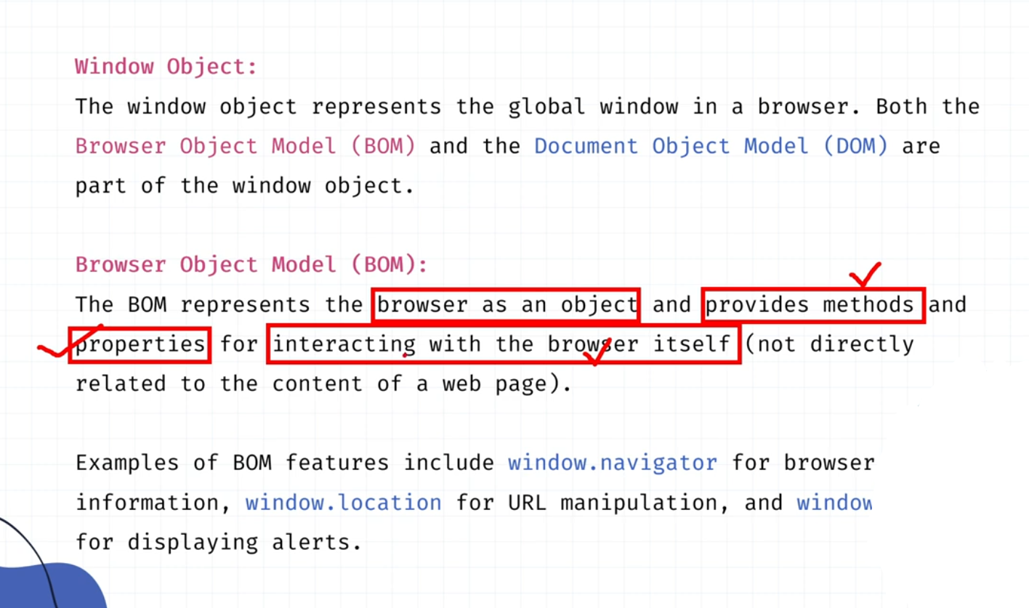

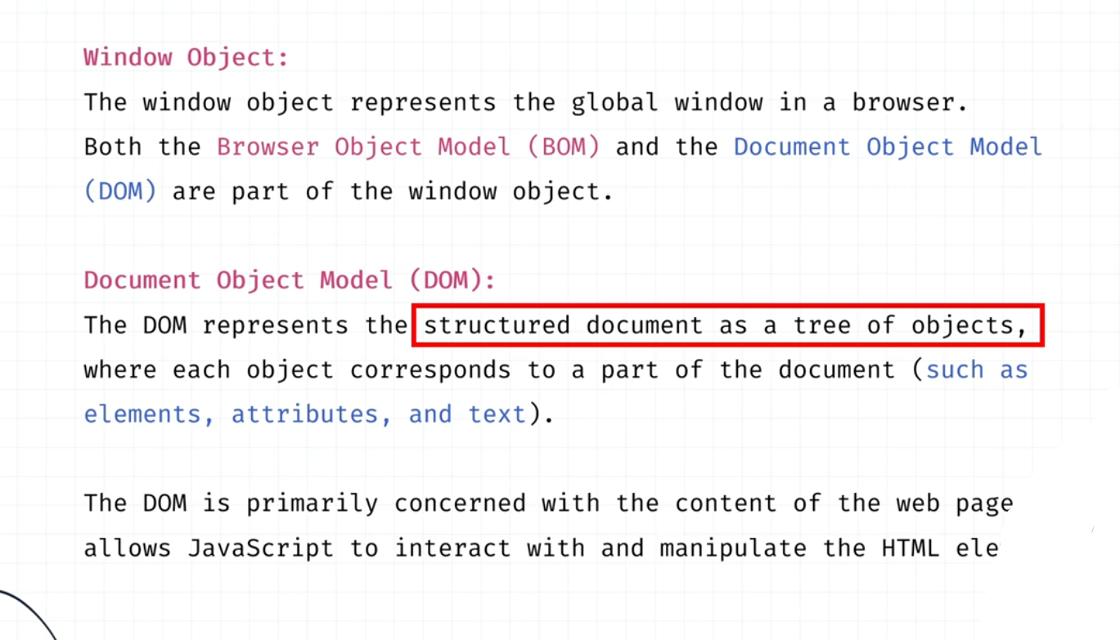

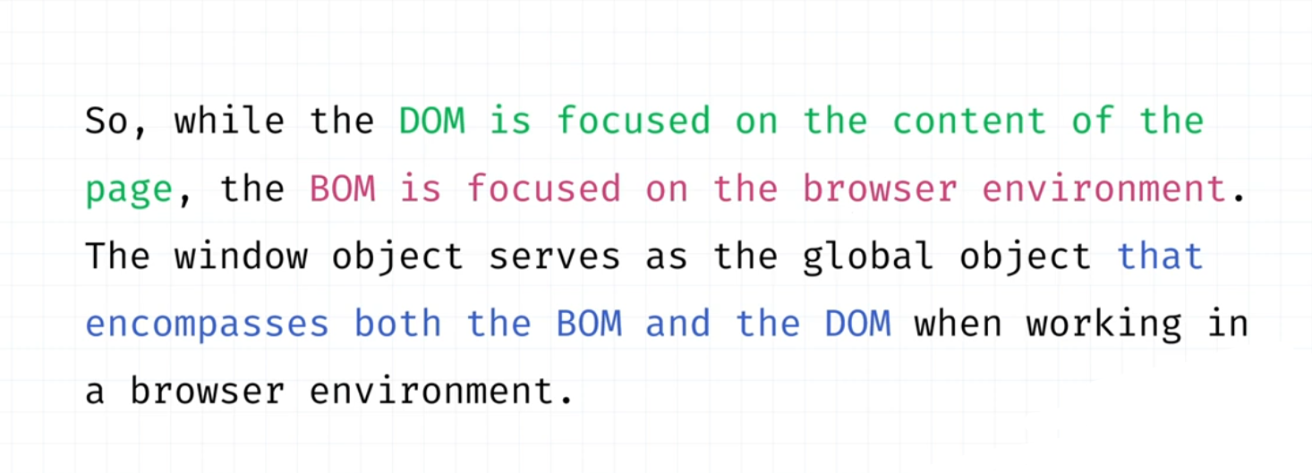

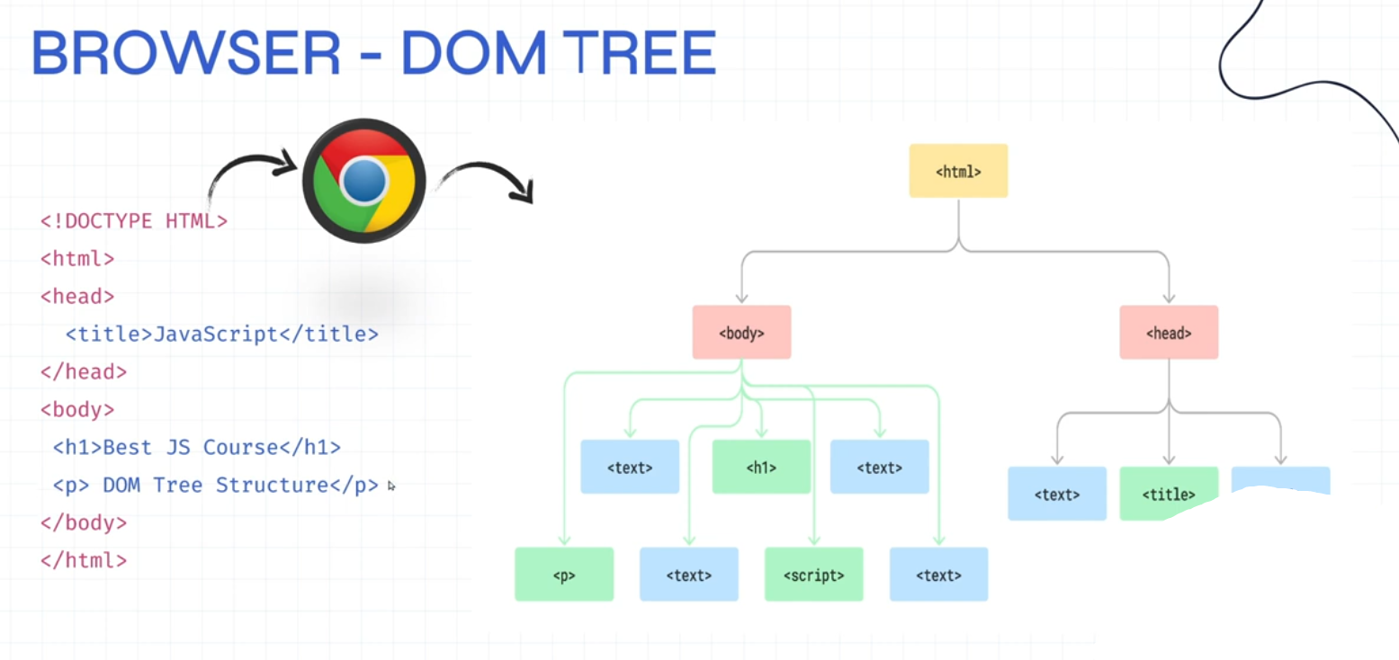

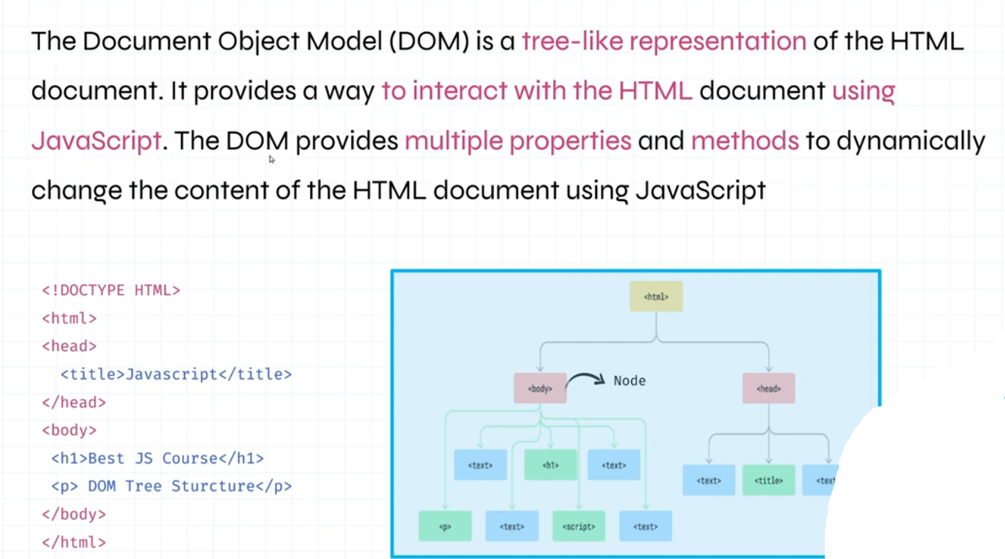

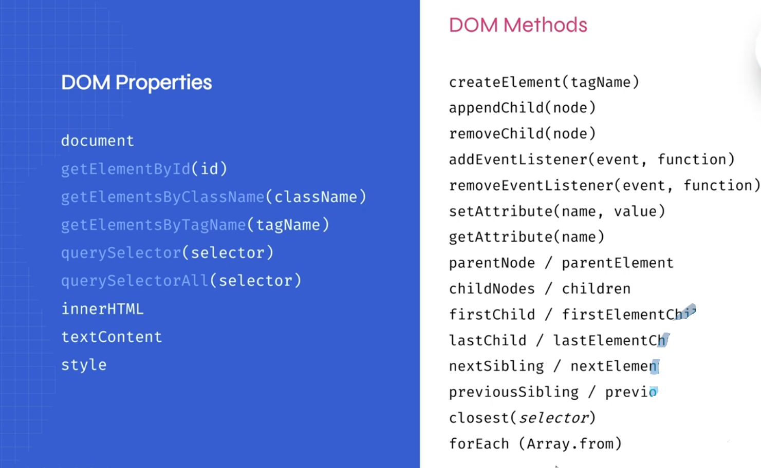

## **-window.open()**

<button onclick="window.open('https:*//www.google.com', '_self')*">Google self</button>

<button onclick="window.open('https:*//www.google.com', '_blank')*">Google new tab</button>

## **window.history()**

<button onclick="window.history.back()">Go back</button>

<button onclick="window.history.forward()">Go forward</button>

<button onclick="window.history.go(-1)">Go back</button>

<button onclick="window.history.go(1)">Go forward</button>

## **window.location.reload()**

<button onclick="window.location.reload()">Page reload</button>

## **window.location.replace()**

<button onclick="window.location.replace('https:*//www.w3schools.com')*">Page replace can't go back</button>

## **window.location.assign()**

<button onclick="window.location.assign('https:*//www.w3schools.com')*">Page replace can go back</button>

28. Local storage

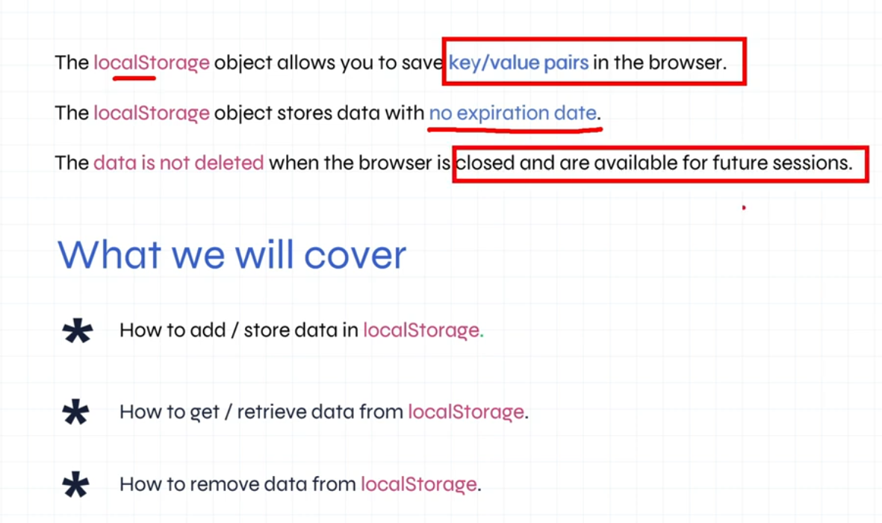

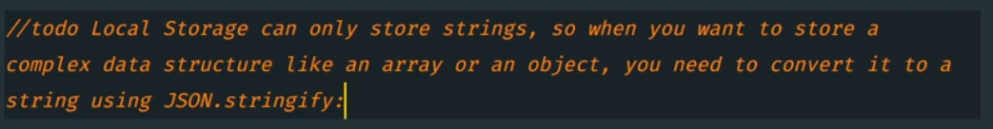

<script>

*// set item*

window.localStorage.setItem("fruits", "Apple");

*// get item*

console.log(window.localStorage.getItem("fruits")); *//Output = Apple*

setTimeout(() => {

*// remove item*

window.localStorage.removeItem("fruits", "Apple");

console.log(window.localStorage.getItem("fruits")); *//Output = null*

}, 3000);

</script>

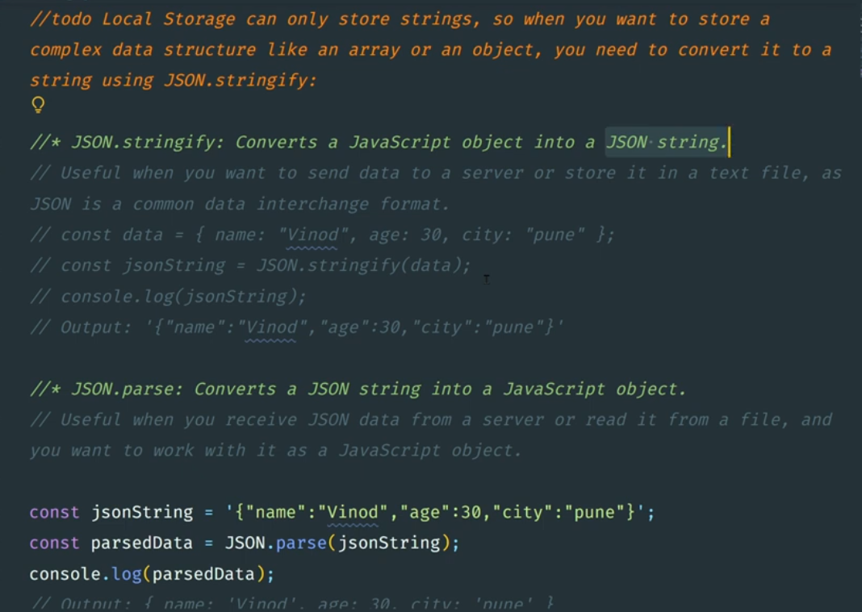

## **-set json data to localStorage**

<script>

*// set json data to localStorage*

let data = {

"userId": 1,

"id": 1,

"title": "delectus aut autem",

"completed": false

}

let stringifyData = JSON.stringify(data);

*// set item*

window.localStorage.setItem("data-set", stringifyData);

*// get item*

let getLsData = window.localStorage.getItem("data-set");

let jsonData = JSON.parse(getLsData);

console.log(jsonData);

</script>

29. Date

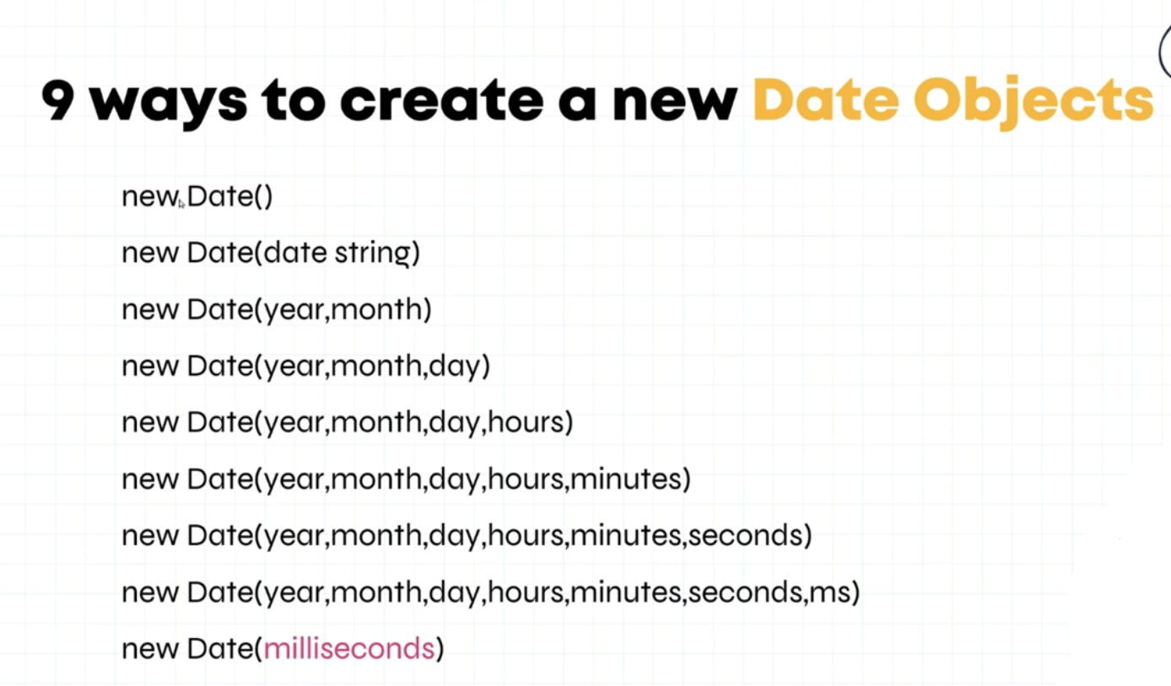

| **Name** | **Description** |
| --- | --- |
| [new Date()](https://www.w3schools.com/jsref/jsref_date_new.asp) | Creates a new Date object |
| [constructor](https://www.w3schools.com/jsref/jsref_constructor_date.asp) | Creates a new Date object |
| [constructor](https://www.w3schools.com/jsref/jsref_constructor_date.asp) | Returns the function that created the Date prototype |
| [getDate()](https://www.w3schools.com/jsref/jsref_getdate.asp) | Returns the day of the month (from 1-31) |
| [getDay()](https://www.w3schools.com/jsref/jsref_getday.asp) | Returns the day of the week (from 0-6) |
| [getFullYear()](https://www.w3schools.com/jsref/jsref_getfullyear.asp) | Returns the year |
| [getHours()](https://www.w3schools.com/jsref/jsref_gethours.asp) | Returns the hour (from 0-23) |
| [getMilliseconds()](https://www.w3schools.com/jsref/jsref_getmilliseconds.asp) | Returns the milliseconds (from 0-999) |
| [getMinutes()](https://www.w3schools.com/jsref/jsref_getminutes.asp) | Returns the minutes (from 0-59) |
| [getMonth()](https://www.w3schools.com/jsref/jsref_getmonth.asp) | Returns the month (from 0-11) |
| [getSeconds()](https://www.w3schools.com/jsref/jsref_getseconds.asp) | Returns the seconds (from 0-59) |
| [getTime()](https://www.w3schools.com/jsref/jsref_gettime.asp) | Returns the number of milliseconds since midnight Jan 1 1970, and a specified date |
| [getTimezoneOffset()](https://www.w3schools.com/jsref/jsref_gettimezoneoffset.asp) | Returns the time difference between UTC time and local time, in minutes |
| [getUTCDate()](https://www.w3schools.com/jsref/jsref_getutcdate.asp) | Returns the day of the month, according to universal time (from 1-31) |
| [getUTCDay()](https://www.w3schools.com/jsref/jsref_getutcday.asp) | Returns the day of the week, according to universal time (from 0-6) |
| [getUTCFullYear()](https://www.w3schools.com/jsref/jsref_getutcfullyear.asp) | Returns the year, according to universal time |
| [getUTCHours()](https://www.w3schools.com/jsref/jsref_getutchours.asp) | Returns the hour, according to universal time (from 0-23) |
| [getUTCMilliseconds()](https://www.w3schools.com/jsref/jsref_getutcmilliseconds.asp) | Returns the milliseconds, according to universal time (from 0-999) |
| [getUTCMinutes()](https://www.w3schools.com/jsref/jsref_getutcminutes.asp) | Returns the minutes, according to universal time (from 0-59) |
| [getUTCMonth()](https://www.w3schools.com/jsref/jsref_getutcmonth.asp) | Returns the month, according to universal time (from 0-11) |
| [getUTCSeconds()](https://www.w3schools.com/jsref/jsref_getutcseconds.asp) | Returns the seconds, according to universal time (from 0-59) |
| getYear() | Deprecated. Use the [getFullYear()](https://www.w3schools.com/jsref/jsref_getfullyear.asp) method instead |
| [now()](https://www.w3schools.com/jsref/jsref_now.asp) | Returns the number of milliseconds since midnight Jan 1, 1970 |
| [parse()](https://www.w3schools.com/jsref/jsref_parse.asp) | Parses a date string and returns the number of milliseconds since January 1, 1970 |
| [prototype](https://www.w3schools.com/jsref/jsref_prototype_date.asp) | Allows you to add properties and methods to an object |
| [setDate()](https://www.w3schools.com/jsref/jsref_setdate.asp) | Sets the day of the month of a date object |
| [setFullYear()](https://www.w3schools.com/jsref/jsref_setfullyear.asp) | Sets the year of a date object |
| [setHours()](https://www.w3schools.com/jsref/jsref_sethours.asp) | Sets the hour of a date object |
| [setMilliseconds()](https://www.w3schools.com/jsref/jsref_setmilliseconds.asp) | Sets the milliseconds of a date object |
| [setMinutes()](https://www.w3schools.com/jsref/jsref_setminutes.asp) | Set the minutes of a date object |
| [setMonth()](https://www.w3schools.com/jsref/jsref_setmonth.asp) | Sets the month of a date object |
| [setSeconds()](https://www.w3schools.com/jsref/jsref_setseconds.asp) | Sets the seconds of a date object |
| [setTime()](https://www.w3schools.com/jsref/jsref_settime.asp) | Sets a date to a specified number of milliseconds after/before January 1, 1970 |
| [setUTCDate()](https://www.w3schools.com/jsref/jsref_setutcdate.asp) | Sets the day of the month of a date object, according to universal time |
| [setUTCFullYear()](https://www.w3schools.com/jsref/jsref_setutcfullyear.asp) | Sets the year of a date object, according to universal time |
| [setUTCHours()](https://www.w3schools.com/jsref/jsref_setutchours.asp) | Sets the hour of a date object, according to universal time |
| [setUTCMilliseconds()](https://www.w3schools.com/jsref/jsref_setutcmilliseconds.asp) | Sets the milliseconds of a date object, according to universal time |
| [setUTCMinutes()](https://www.w3schools.com/jsref/jsref_setutcminutes.asp) | Set the minutes of a date object, according to universal time |
| [setUTCMonth()](https://www.w3schools.com/jsref/jsref_setutcmonth.asp) | Sets the month of a date object, according to universal time |
| [setUTCSeconds()](https://www.w3schools.com/jsref/jsref_setutcseconds.asp) | Set the seconds of a date object, according to universal time |
| setYear() | Deprecated. Use the [setFullYear()](https://www.w3schools.com/jsref/jsref_setfullyear.asp) method instead |
| [toDateString()](https://www.w3schools.com/jsref/jsref_todatestring.asp) | Converts the date portion of a Date object into a readable string |
| toGMTString() | Deprecated. Use the [toUTCString()](https://www.w3schools.com/jsref/jsref_toutcstring.asp) method instead |
| [toISOString()](https://www.w3schools.com/jsref/jsref_toisostring.asp) | Returns the date as a string, using the ISO standard |
| [toJSON()](https://www.w3schools.com/jsref/jsref_tojson.asp) | Returns the date as a string, formatted as a JSON date |
| [toLocaleDateString()](https://www.w3schools.com/jsref/jsref_tolocaledatestring.asp) | Returns the date portion of a Date object as a string, using locale conventions |
| [toLocaleTimeString()](https://www.w3schools.com/jsref/jsref_tolocaletimestring.asp) | Returns the time portion of a Date object as a string, using locale conventions |
| [toLocaleString()](https://www.w3schools.com/jsref/jsref_tolocalestring.asp) | Converts a Date object to a string, using locale conventions |
| [toString()](https://www.w3schools.com/jsref/jsref_tostring_date.asp) | Converts a Date object to a string |
| [toTimeString()](https://www.w3schools.com/jsref/jsref_totimestring.asp) | Converts the time portion of a Date object to a string |
| [toUTCString()](https://www.w3schools.com/jsref/jsref_toutcstring.asp) | Converts a Date object to a string, according to universal time |
| [UTC()](https://www.w3schools.com/jsref/jsref_utc.asp) | Returns the number of milliseconds in a date since midnight of January 1, 1970, according to UTC time |
| [valueOf()](https://www.w3schools.com/jsref/jsref_valueof_date.asp) | Returns the primitive value of a Date object |

30. Timing based event

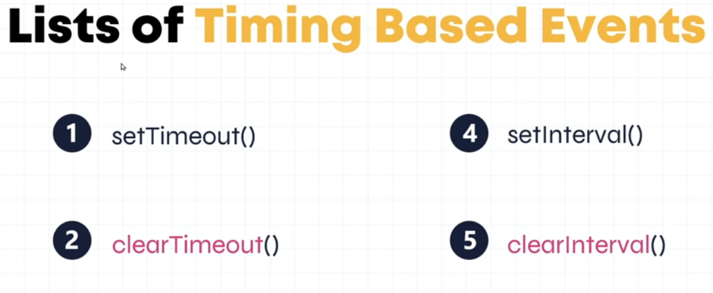

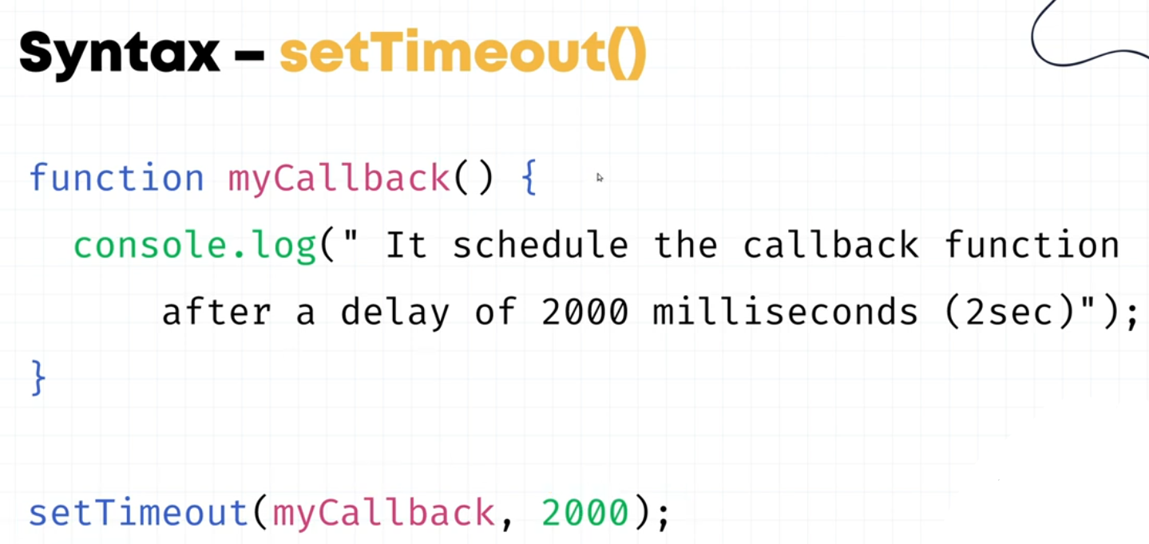

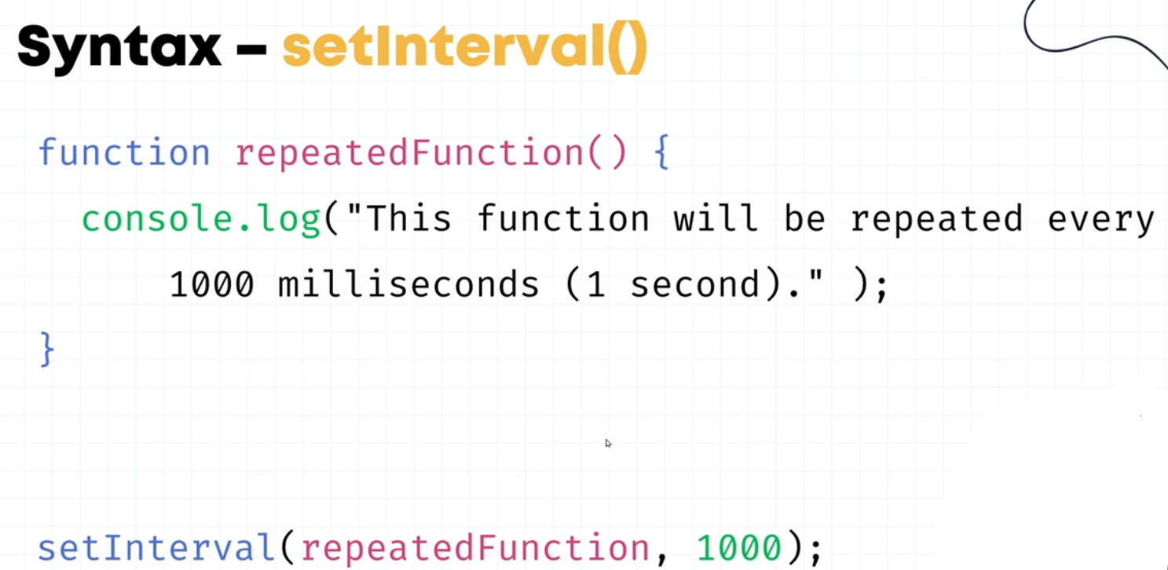

<script>

let date = new Date();

setTimeout(() => {

console.log(date);

}, 2000);

setInterval(() => {

console.log(date);

}, 2000);

*// Clear interval below*

function setIntervalFun() {

console.log(date);

}

const setIntervalContainer = setInterval(setIntervalFun, 1000);

setTimeout(() => {

clearInterval(setIntervalContainer);

}, 2000);

</script>

31. Object

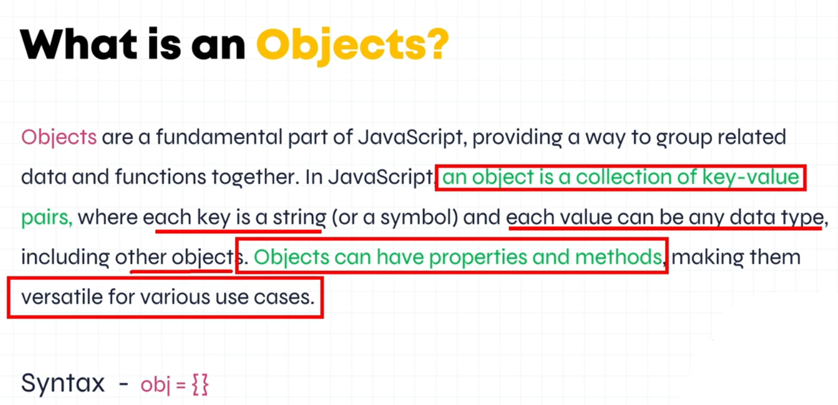

<script>

let obj = {

name: "Mohit",

id: 13001,

role: "Web Designer",

greet: function () {

console.log("hello " + this.name);

}

}

console.log(obj);

obj.greet();

</script>

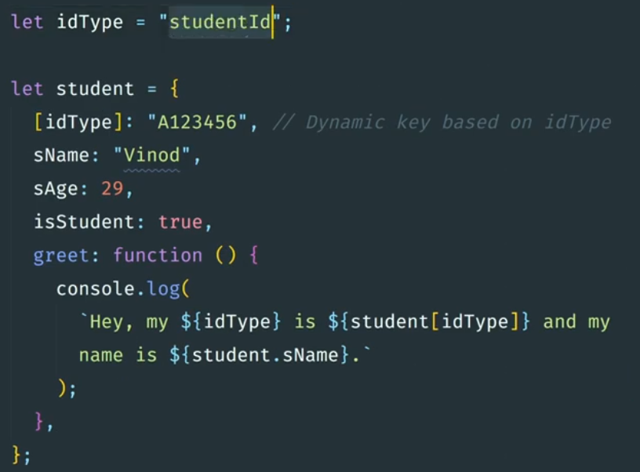

<script>

let id = "EmpId";

let obj = {

name: "Mohit",

[id]: 13001,

role: "Web Designer",

greet: function () {

console.log(`hello your ${id} is ${obj[id]}`);

}

}

obj.greet(); *//Output = hello your EmpId is 13001*

</script>

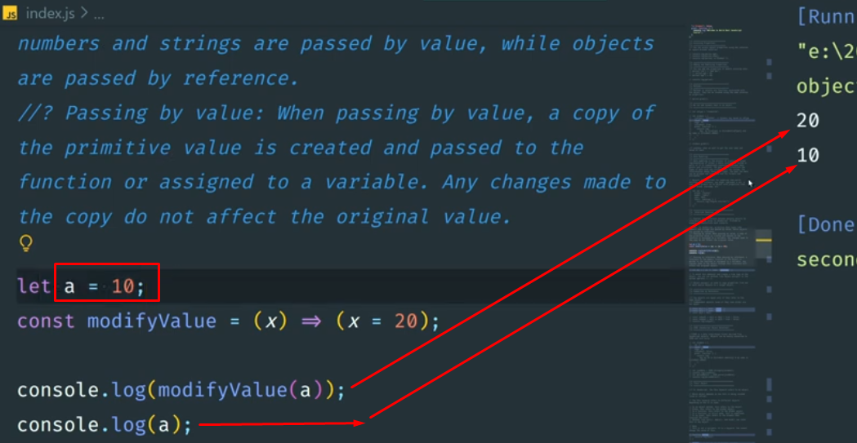

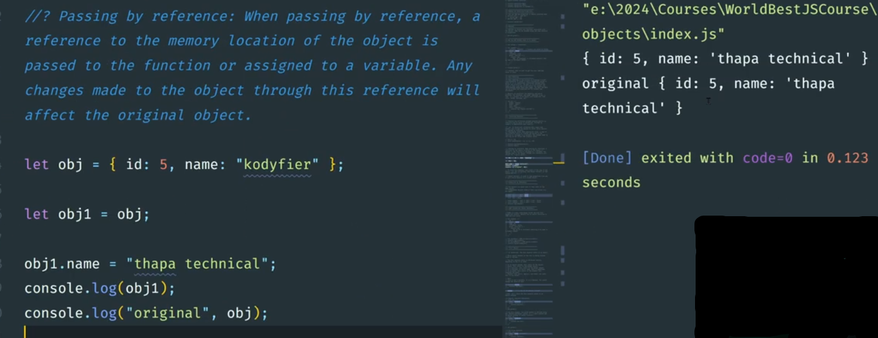

11. Tricky Questions

<script>

let a = 0.1;

let b = 0.2;

let c = a + b;

console.log(c); *//Output is 0.30000000000000004*

*// to fix this case by using toFixed*

console.log(c.toFixed(2)); *//Output is 0.30*

</script>

## **-Number is positive or negative**

<script>

*// Write a program to check if number is positive or negative*

let number = 10;

let checkStatus;

if (number == 0) {

checkStatus = "Zero";

} else if (number > 0) {

checkStatus = "Positive";

} else {

checkStatus = "Negative";

}

console.log(checkStatus);

</script>

## **-Check Even Odd**

<script>

let number = 10;

let checkStatus;

if (number % 2 === 0) {

checkStatus = "Even";

} else {

checkStatus = "Odd";

}

console.log(checkStatus);*//Output is Even*

</script>

## **-Check Shapes using switch statement**

<script>

let a = 10; *// Example radius for circle*

let b = 20; *// Example value for rectangle*

let shape = "circle"; *// Change to "square", "rectangle", or "circle" as needed*

let shapeDimensions;

switch (shape) {

case "square":

shapeDimensions = a * a;

break;

case "rectangle":

shapeDimensions = a * b;

break;

case "circle":

shapeDimensions = Math.PI * a * a;

break;

default:

shapeDimensions = "default shape";

}

console.log(shape + " " + shapeDimensions);

</script>

## **-Create table using while**

<script>

let tableOf = 5;

let num = 1;

while (num <= 10) {

console.log(`${tableOf} * ${num} = ${num * tableOf}`);

num++;

}

</script>

## **-Create prompt with do-while loop** It will repeatedly show the prompt until the user inputs a valid number.

<script>

let userInput;

let positiveNum;

do {

userInput = prompt("Enter your number");

positiveNum = parseFloat(userInput);

} while (isNaN(positiveNum) || (positiveNum < 0));

</script>

## **-Check sum on numbers from 1-10 using for loop**

<script>

let sum = 0;

for (let i = 1; i <= 10; i++) {

sum = sum + i;

console.log(sum);

}

console.log(sum);

</script>

## **-Check prime number**

**What is Prime number:** A number that can be divided exactly only by itself and 1, for example 7, 17 and 41.

<script>

let num = 17;

let isPrime = true;

for (let i = 2; i < num - 1; i++) {

if (num % i == 0) {

isPrime = false;

break;

}

}

console.log(isPrime);

if (isPrime) {

console.log(`${num} is a Prime number`);

} else {

console.log(`${num} is not a Prime number`);

}

</script>

## **-Check leap year using for loop**

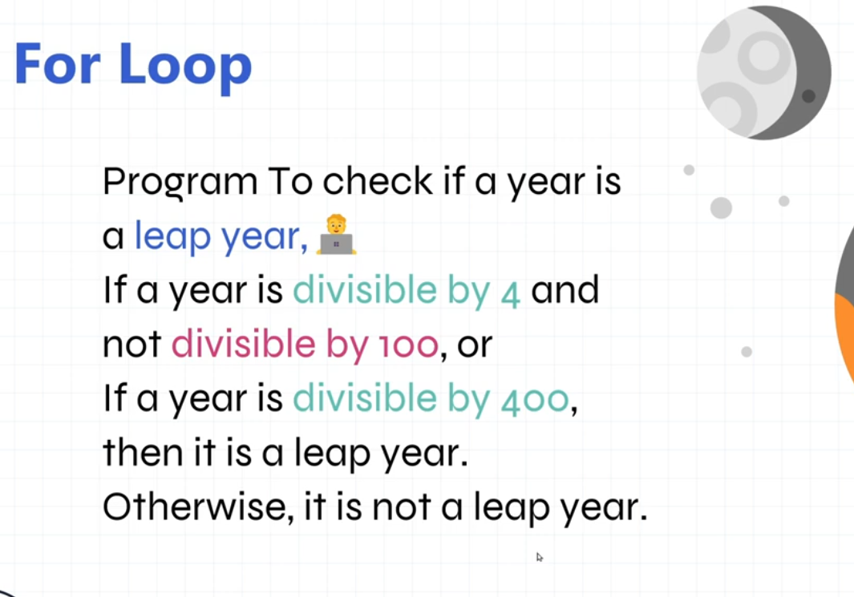

<script>

let year = 2024;

if (((year % 4 == 0) && (year % 100 !== 0)) || (year % 400 === 0)) {

console.log(`${year} is leap year`);

} else {

console.log(`${year} is not leap year`);

}

</script>

## **-Create Star pattern using for loop**

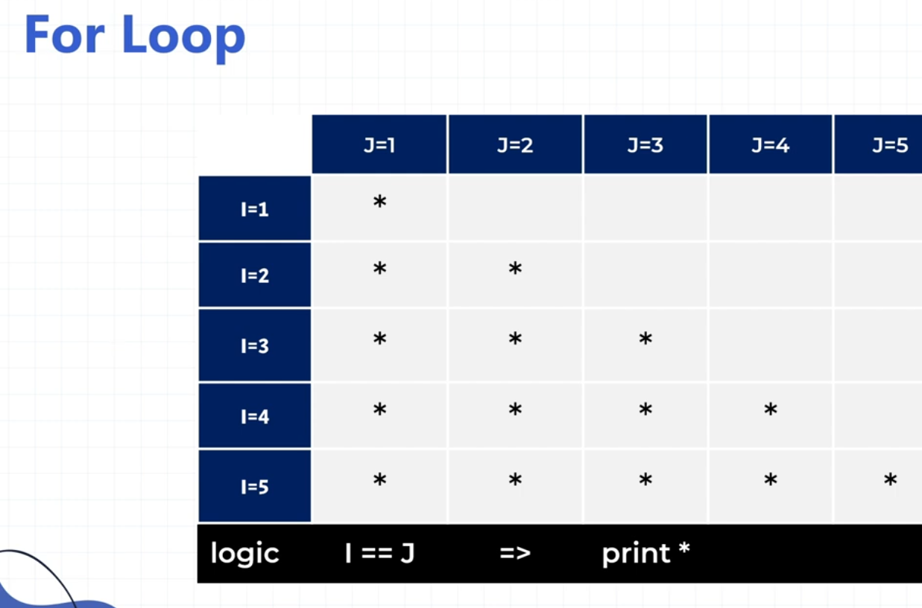

<script>

for (let i = 1; i <= 5; i++) {

for (let j = 1; j <= i; j++) {

document.write("⭐")

}

document.write("<br>")

}

</script>

## **-Create basic Calculator using fat arrow**

<script>

const calculator = (*a*, *b*, *operator*) => {

switch (*operator*) {

case "+":

return *a* + *b*;

case "-":

return *a* - *b*;

case "/":

return *a* / *b*;

default:

break;

}

}

console.log(calculator(5, 10, "+"));

console.log(calculator(5, 10, "-"));

console.log(calculator(10, 0, "/"));

</script>

## **-Reverse string without inbuilt reverse str method**

<script>

*// Reverse string without inbuilt reverse str method*

const isReverse = (*str*) => {

let reverse = "";

for (let i = *str*.length - 1; i >= 0; i--) {

reverse = reverse + *str*[i]

}

return reverse;

}

console.log(isReverse("Mohit Verma")); *//Output = amreV tihoM*

</script>

## 

## **-Check Palindrome or not**

A palindrome is a word, number, phrase, or other sequence of symbols that reads the same backwards as forwards, such as madam or racecar, level, radar, the date "22/02/2022"

<script>

const isReverse = (*str*) => {

let reverse = "";

for (let i = *str*.length - 1; i >= 0; i--) {

reverse = reverse + *str*[i]

}

return (*str* === reverse) ? true : false;

}

console.log(isReverse("level")); *//Output = true*

</script>

## **-Add dec at the end of an array**

<script>

*// Add dec at the end of an array*

let fruits = ["jan", "feb", "march", "april", "may"];

fruits.splice(fruits.length, 0, "dec");

console.log(fruits); *//Output = ['jan', 'feb', 'march', 'april', 'may', 'dec']*

</script>

## **-Update march to March in array**

<script>

*// Update march to March in array*

let fruits = ["jan", "feb", "march", "april", "may"];

let findIndex = fruits.indexOf("march");

fruits.splice(findIndex, 1, "March");

console.log(fruits); *// Output = ['jan', 'feb', 'March', 'april', 'may']*

</script>

## **-Update cart using filter method**

<script>

let deletedVal = 5;

let cartValues = [1, 2, 3, 4, 5, 6, 7, 8, 9, 5];

let updatedCart = cartValues.filter(*element* => {

return *element* !== deletedVal;

});

console.log(updatedCart); *//Output = [1, 2, 3, 4, 6, 7, 8, 9]*

</script>

## **-Search for products with a price greater than 500 using the filter method.**

<script>

let products = [

{

name: "Laptop",

price: 1200

},

{

name: "Mobile",

price: 500

},

{

name: "Watch",

price: 700

},

{

name: "Tablet",

price: 800

},

];

let filteredProducts = products.filter(*element* => {

return *element*.price > 500;

});

console.log(filteredProducts);

</script>

## **-Filter unique values**

<script>

let numbers = [1, 2, 3, 4, 5, 6, 7, 4, 8, 9, 4];

let filteredUnique = numbers.filter((*element*, *index*, *arr*) => {

return *arr*.indexOf(*element*) === *index*;

});

console.log(filteredUnique); *//Output = [1, 2, 3, 4, 5, 6, 7, 8, 9]*

</script>

## **-Filter unique values using new set() method**

<script>

let numbers = [1, 2, 3, 4, 5, 6, 7, 4, 8, 9, 4];

let filteredUnique = [...new Set(numbers)];

console.log(filteredUnique); *// Output: [1, 2, 3, 4, 5, 6, 7, 8, 9]*

</script>

## **-Sum of all array's value using for of loop with es6 rest parameter**

<script>

function fun(...*input*) {

let sum = 0;

for (let i of *input*) {

sum += i;

}

return sum;

}

console.log(fun(1, 2)); *//3*

console.log(fun(1, 2, 3)); *//6*

console.log(fun(1, 2, 3, 4, 5)); *//15*

</script>

## 

## **-print a - z**

<script>

const startFrom = "a".charCodeAt(0);

const endFrom = "z".charCodeAt(0);

for (let i = startFrom; i <= endFrom; i++) {

console.log(String.fromCharCode(i));

}

</script>

## **-check vowels in string**

<script>

let vowels = "aeiou";

console.log(vowels);

const testFun = (*str*) => {

for (const element of vowels) {

if (!*str*.includes(element)) {

return false

};

}

console.log("True");

}

testFun("Hello World!");

</script>

## **-pangram checker**

<script>

*// pangram checker*

function pangramChecker(*sentence*) {

let sentenceArr = *sentence*.lowerCase().split("");

const sentenceCheck = sentenceArr.filter((*element*) => {

return ((*element*.charCodeAt(0) >= "a".charCodeAt(0)) && (*element*.charCodeAt(0) <= "z".charCodeAt(0)));

});

const sentenceCheckRefine = new Set(sentenceCheck); *//for remove duplicate entries*

*// const sentenceCheckRefine = [...new Set(sentenceCheck)]; //convert set to array*

*// console.log(sentenceCheckRefine.size); //check length in set*

if (sentenceCheckRefine.size !== 26) {

alert("Sentence is non pangram");

return false;

} else {

alert("Sentence is pangram");

return true;

}

}

pangramChecker("The quick brown fox jumps over the lazy dog.");

</script>

## **-simple todo list**

<!DOCTYPE html>

<html lang="en">

<head>

<meta charset="UTF-8">

<meta name="viewport" content="width=device-width, initial-scale=1.0">

<title>Document</title>

<style>

@import url('https://fonts.googleapis.com/css2?family=Poppins:ital,wght@0,100;0,200;0,300;0,400;0,500;0,600;0,700;0,800;0,900;1,100;1,200;1,300;1,400;1,500;1,600;1,700;1,800;1,900&display=swap');

* {

margin: 0;

padding: 0;

box-sizing: border-box;

font-family: "Poppins", sans-serif;

}

.todo_sec {

position: relative;

min-height: 100vh;

display: flex;

align-items: center;

justify-content: center;

background-color: #303030;

}

.container {

position: relative;

width: 1140px;

max-width: 100%;

padding: 0 15px;

margin: 0 auto;

}

.box {

position: relative;

padding: 50px;

background-color: #fff;

border-radius: 10px;

}

.box h1 {

font-size: 32px;

font-weight: 400;

color: #111;

margin-bottom: 20px;

}

.box .form_wrap .form_row {

position: relative;

display: flex;

justify-content: space-between;

}

.box .form_wrap .form_row .input_wrap {

position: relative;

width: calc(100% - 220px);

}

.box .form_wrap .form_row .input_wrap input {

width: 100%;

padding: 12px;

border: 1px solid #303030;

font-size: 18px;

}

.box .form_wrap .form_row .input_btn {

position: relative;

width: 200px;

}

.box .form_wrap .form_row .input_btn input {

width: 100%;

border: 1px solid #303030;

font-size: 18px;

padding: 12px;

cursor: pointer;

background-color: tomato;

color: #fff;

}

.box .list_wrap {

position: relative;

border: 1px solid #303030;

margin-top: 40px;

padding: 50px;

}

.box .list_wrap li {

position: relative;

padding: 15px;

color: #111;

list-style-type: none;

background-color: #deebff;

cursor: pointer;

margin-bottom: 10px;

}

</style>

</head>

<body>

<section class="todo_sec">

<div class="container">

<div class="box">

<h1>Simple Todo list</h1>

<div class="form_wrap">

<form>

<div class="form_row">

<div class="input_wrap">

<input type="text" placeholder="Add items here.." id="inputField">

</div>

<div class="input_btn">

<input type="submit" value="Add to list">

</div>

</div>

</form>

</div>

<ul class="list_wrap"></ul>

</div>

</div>

</section>

<script>

let inputField = document.querySelector(".todo_sec #inputField");

let form = document.querySelector(".todo_sec .form_wrap form");

let list_wrap = document.querySelector(".todo_sec .list_wrap");

const todoListFun = () => {

const node = document.createElement("li");

const textnode = document.createTextNode(inputField.value);

node.appendChild(textnode);

list_wrap.appendChild(node);

inputField.value = "";

}

form.addEventListener("submit", function (*event*) {

*event*.preventDefault();

todoListFun();

});

list_wrap.addEventListener("click", function (*event*) {

*event*.target.remove();

});

</script>

</body>

</html>